Name : Kreena Shah

Sapid : 60004210243

Batch : Comps C’32

Subject : Advance Database Management System (ADBMS)

**Experiment No 1 - SQL Programming**

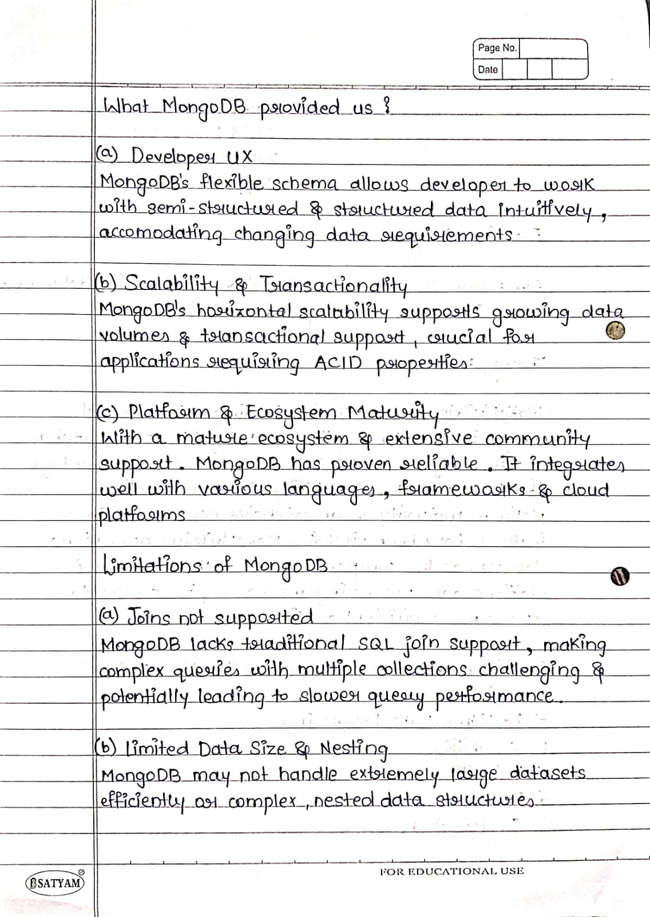

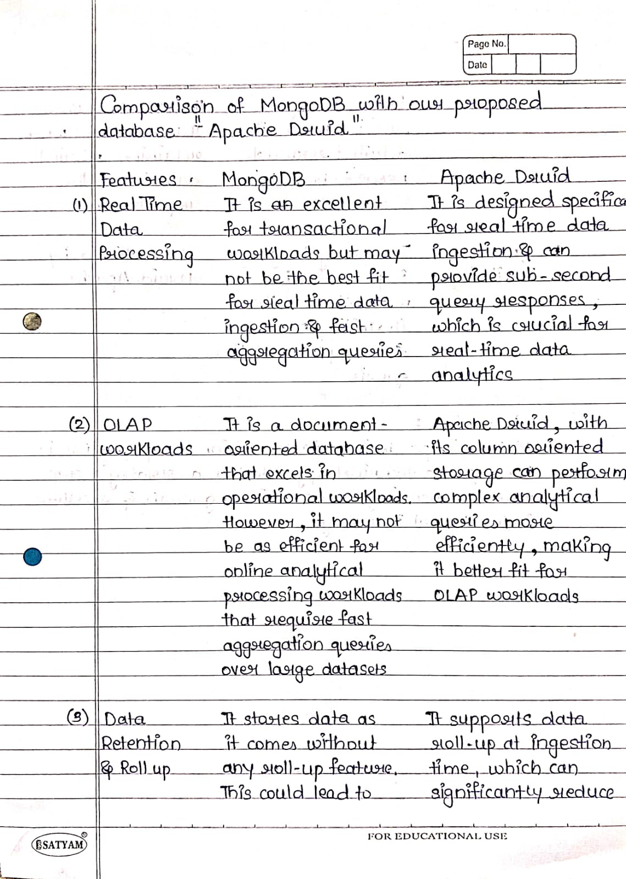

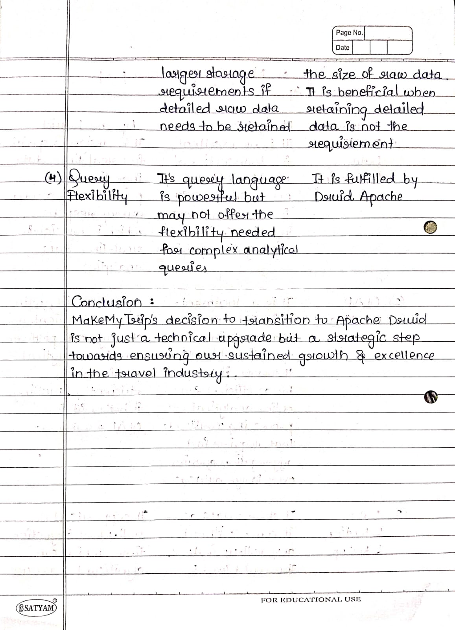

**Experiment No 2 - Query Optimization**

Aim : Simulate Query optimization by applying an SQL Query on any database

Write Ups : 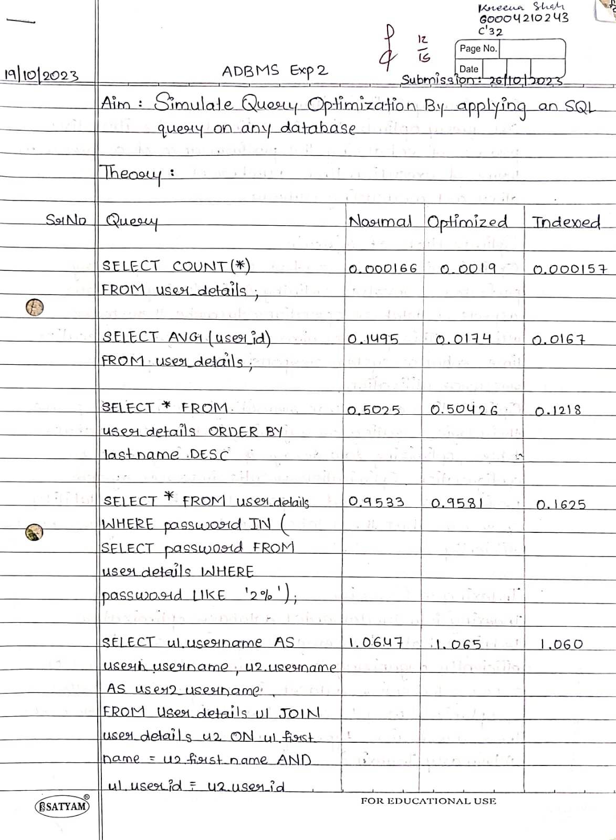

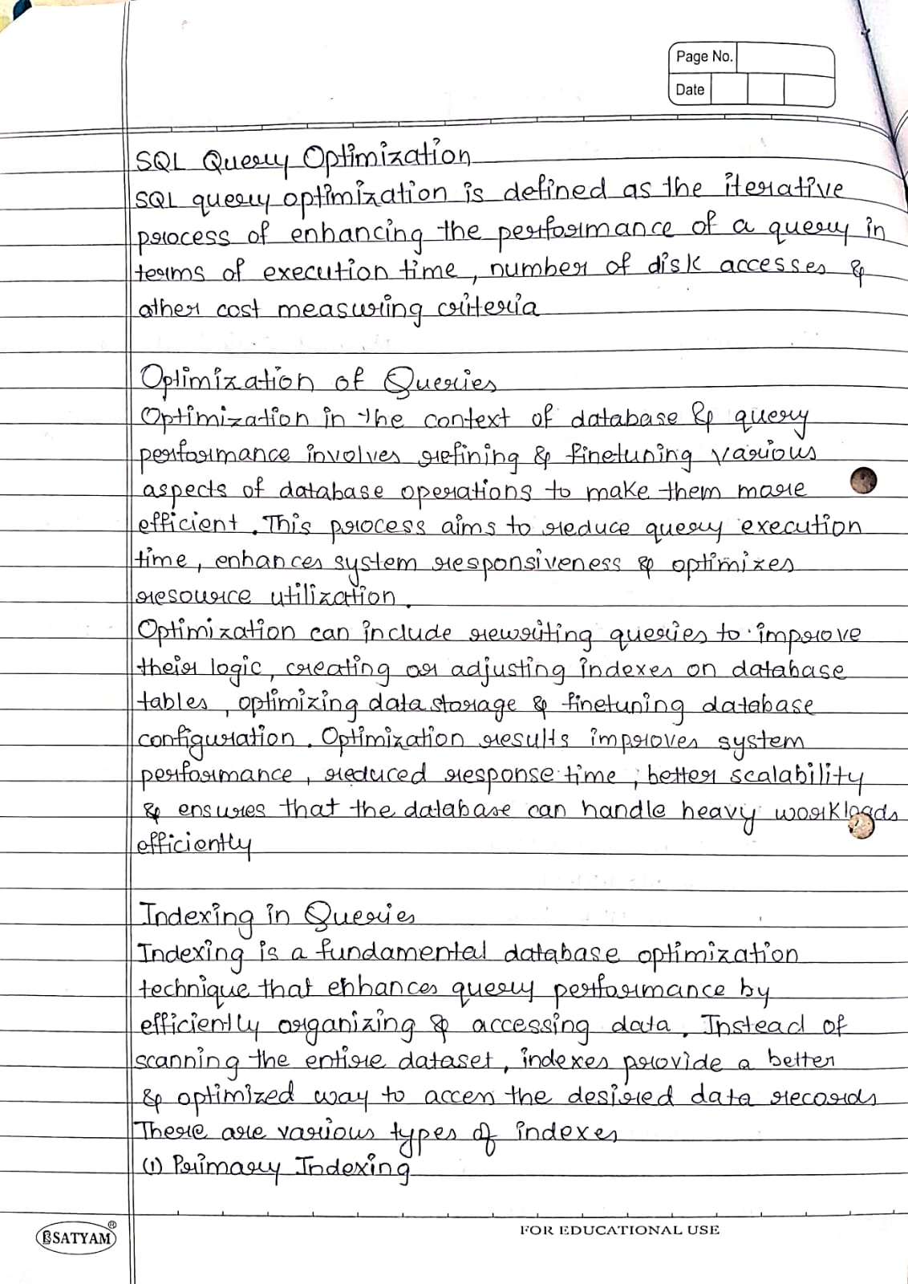

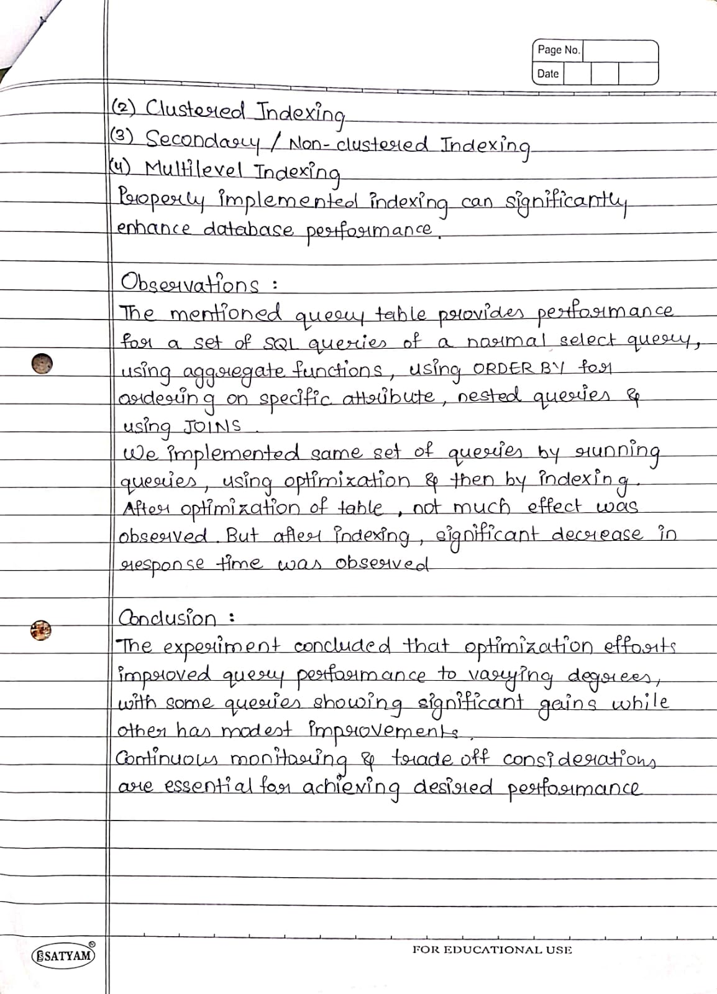

Screenshots :

Simple Query

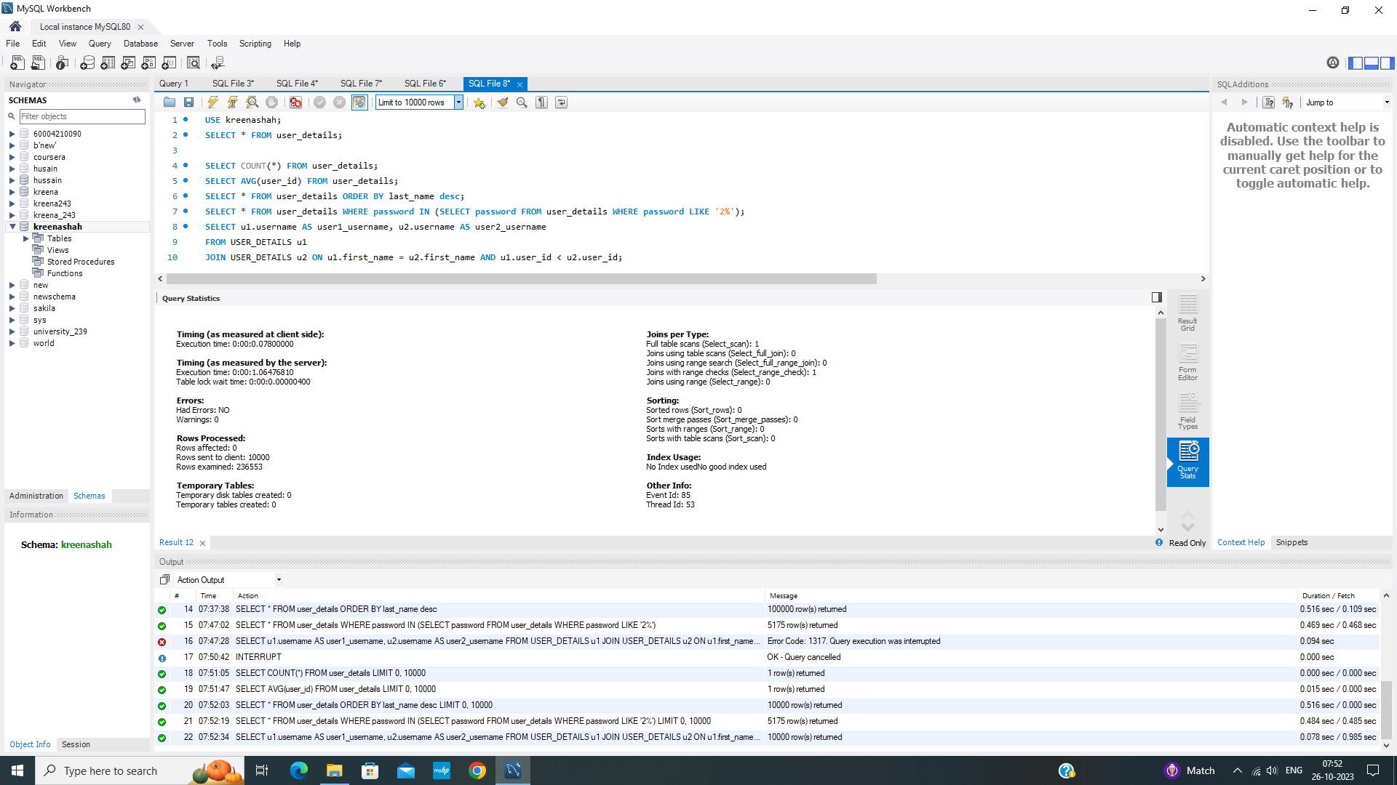

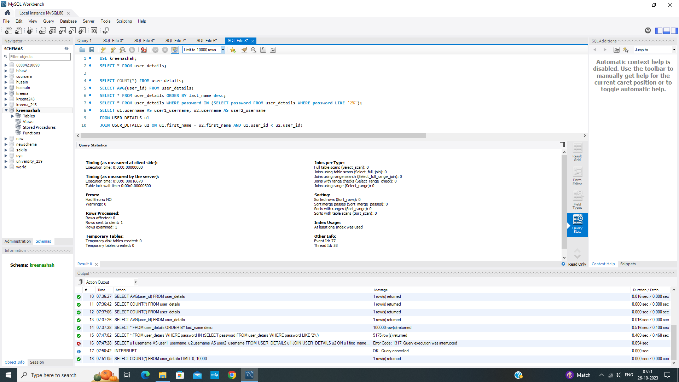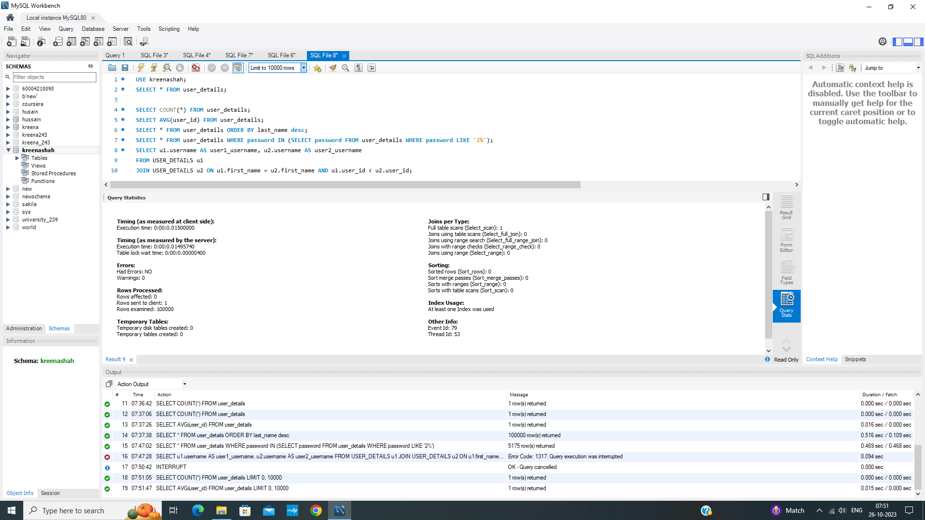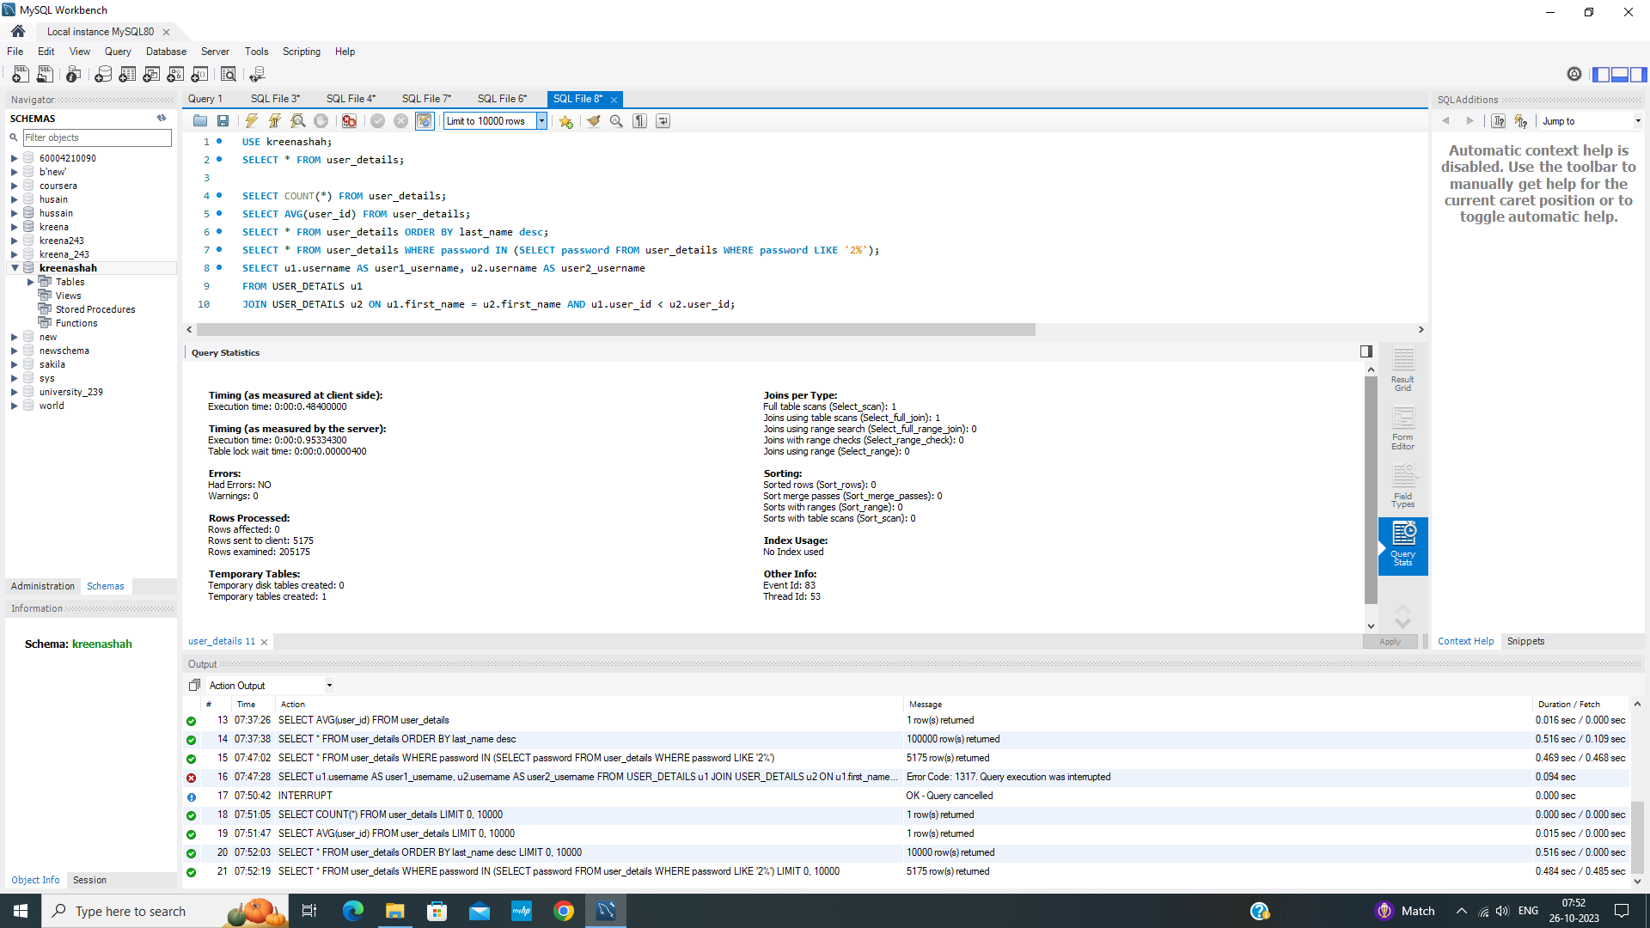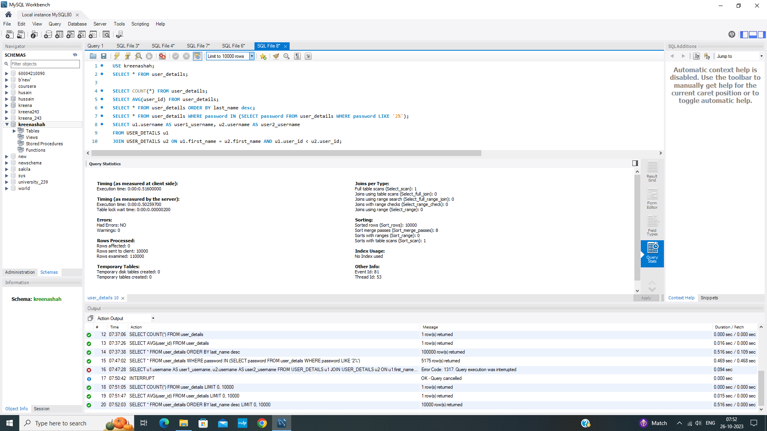

Optimized Query

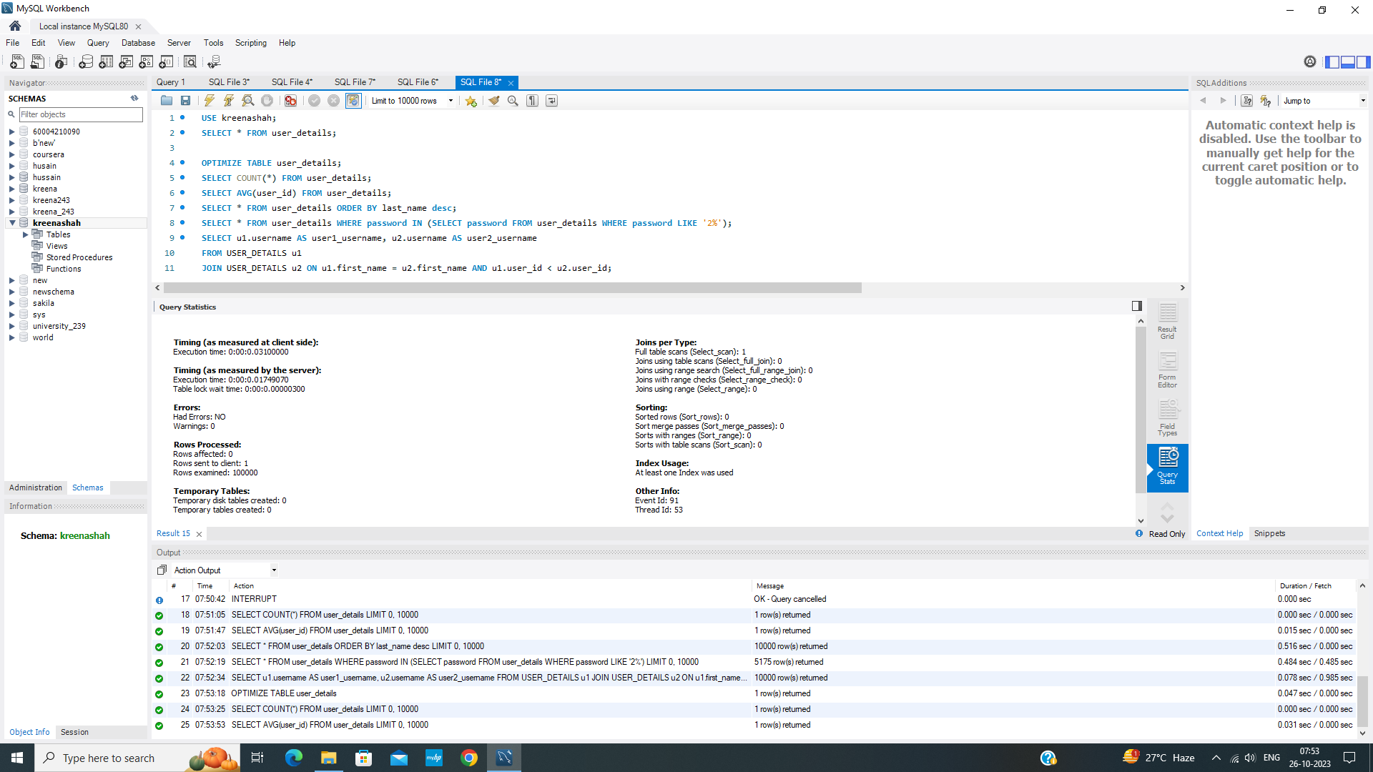

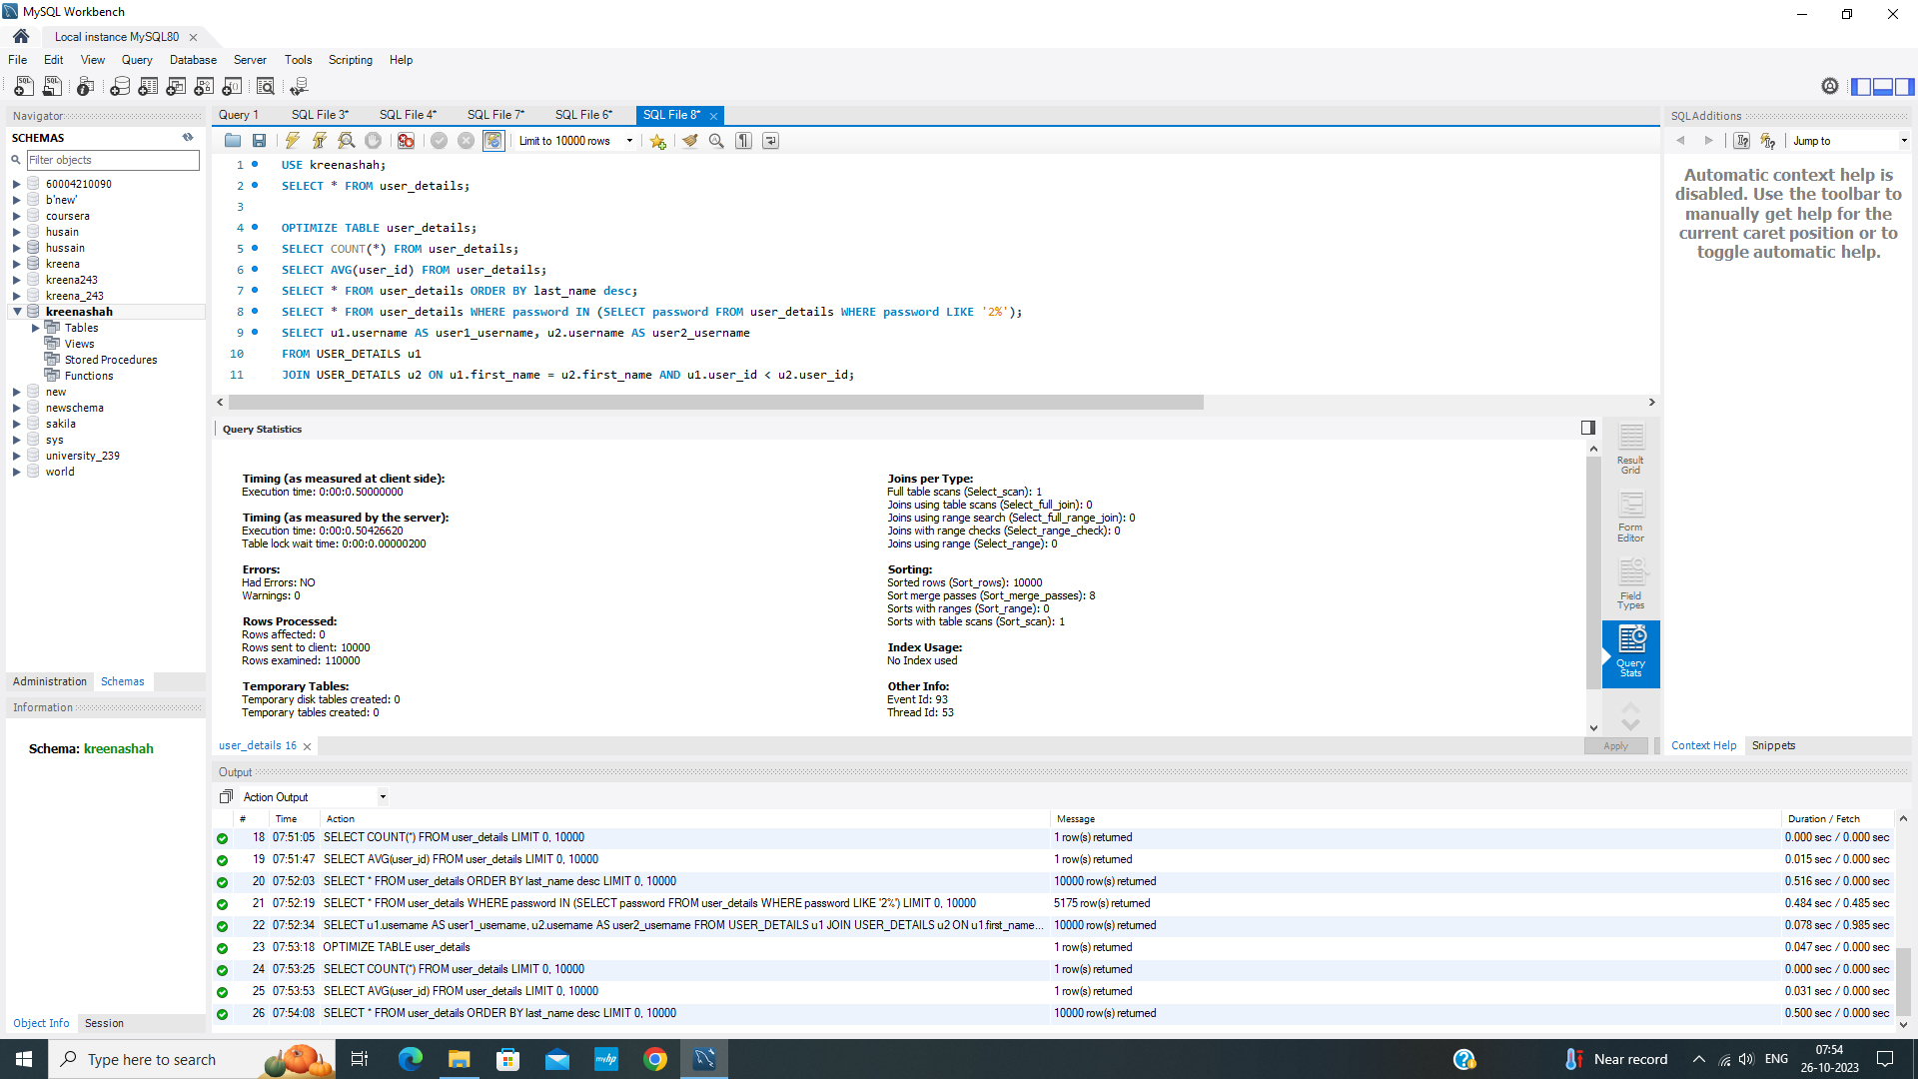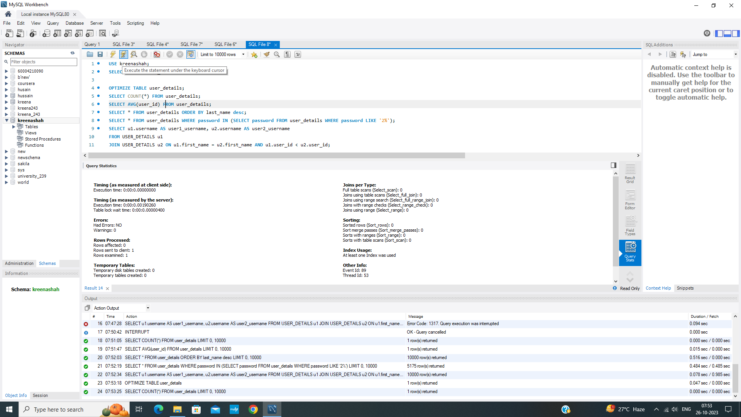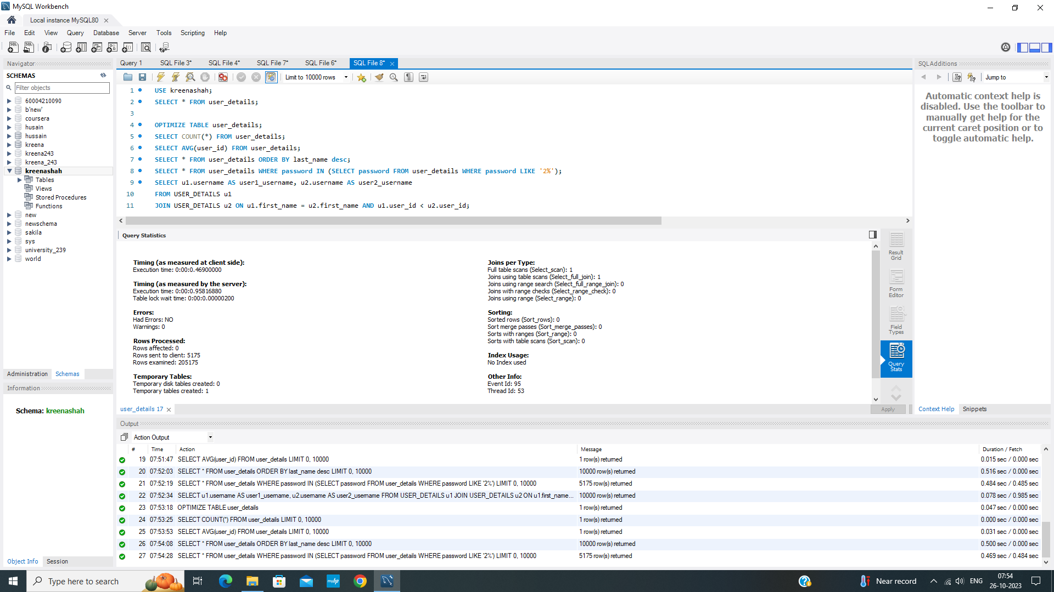

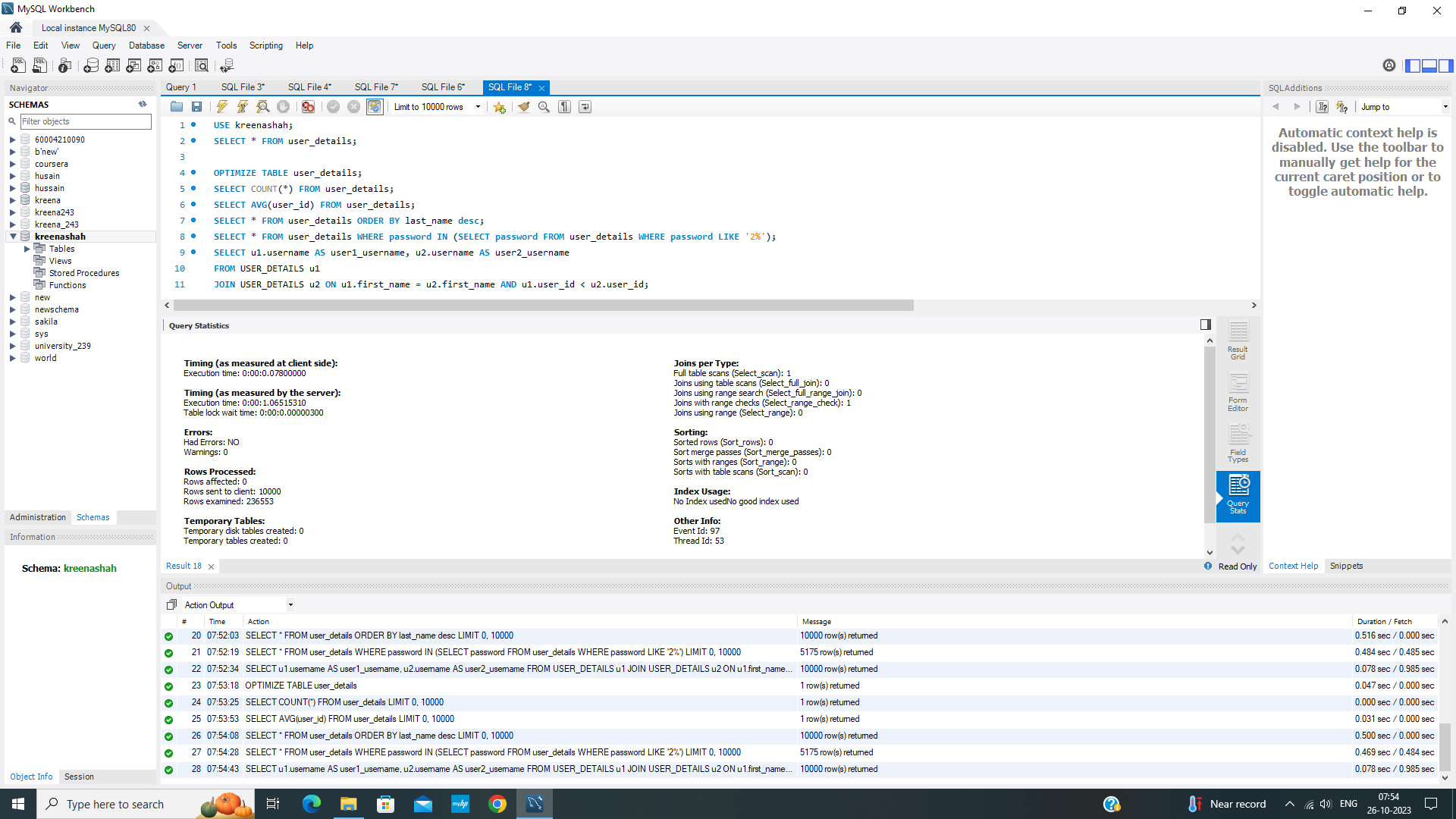

Indexed Query

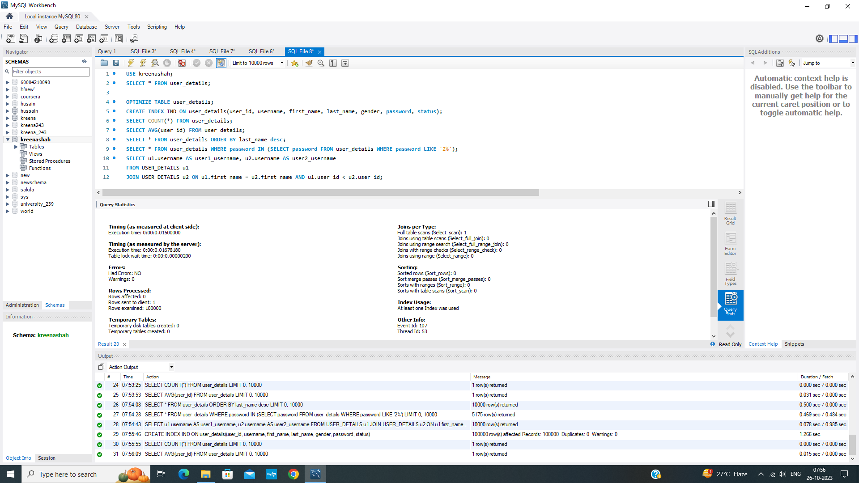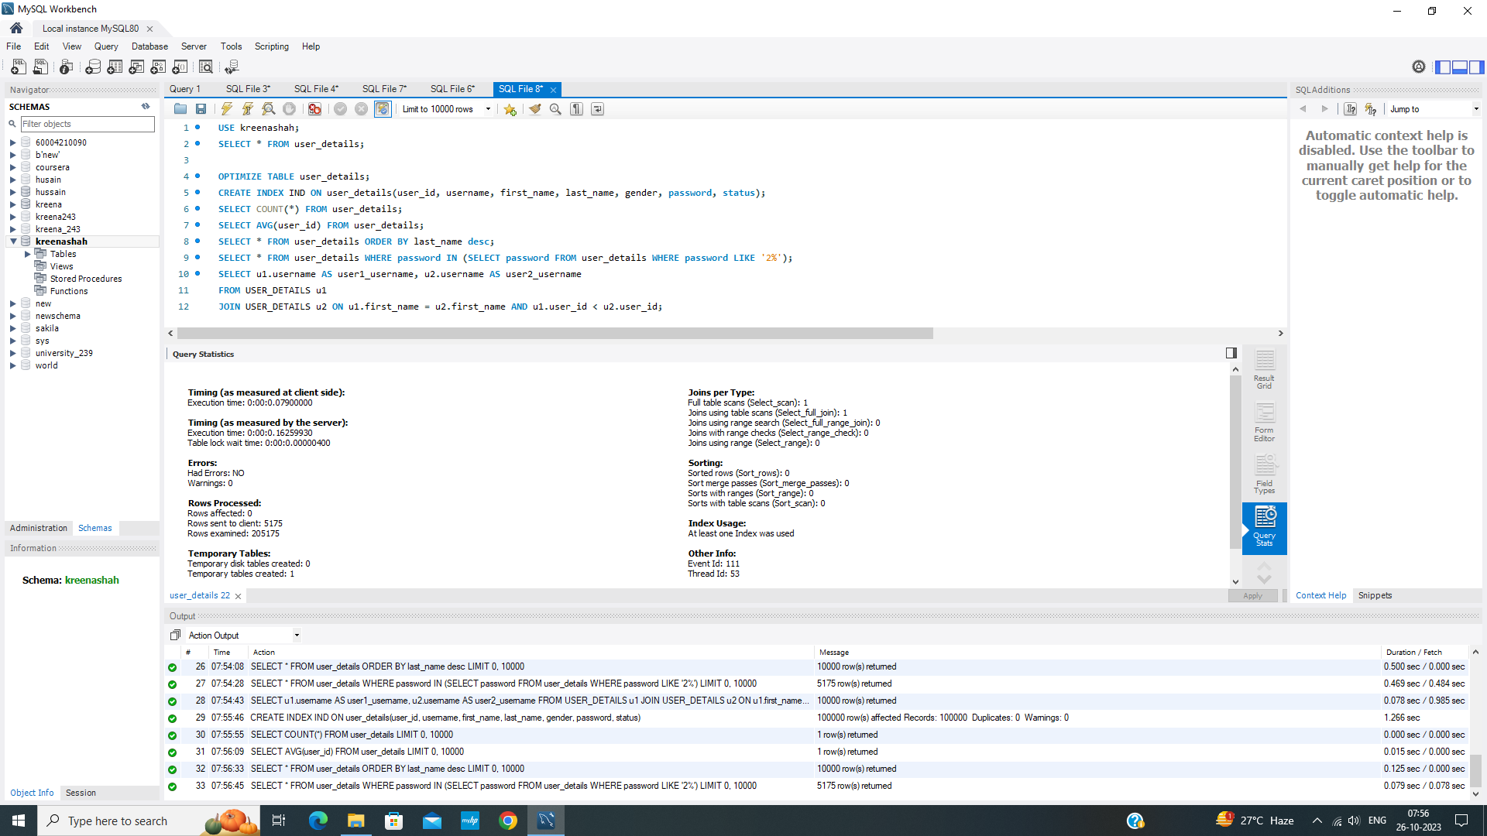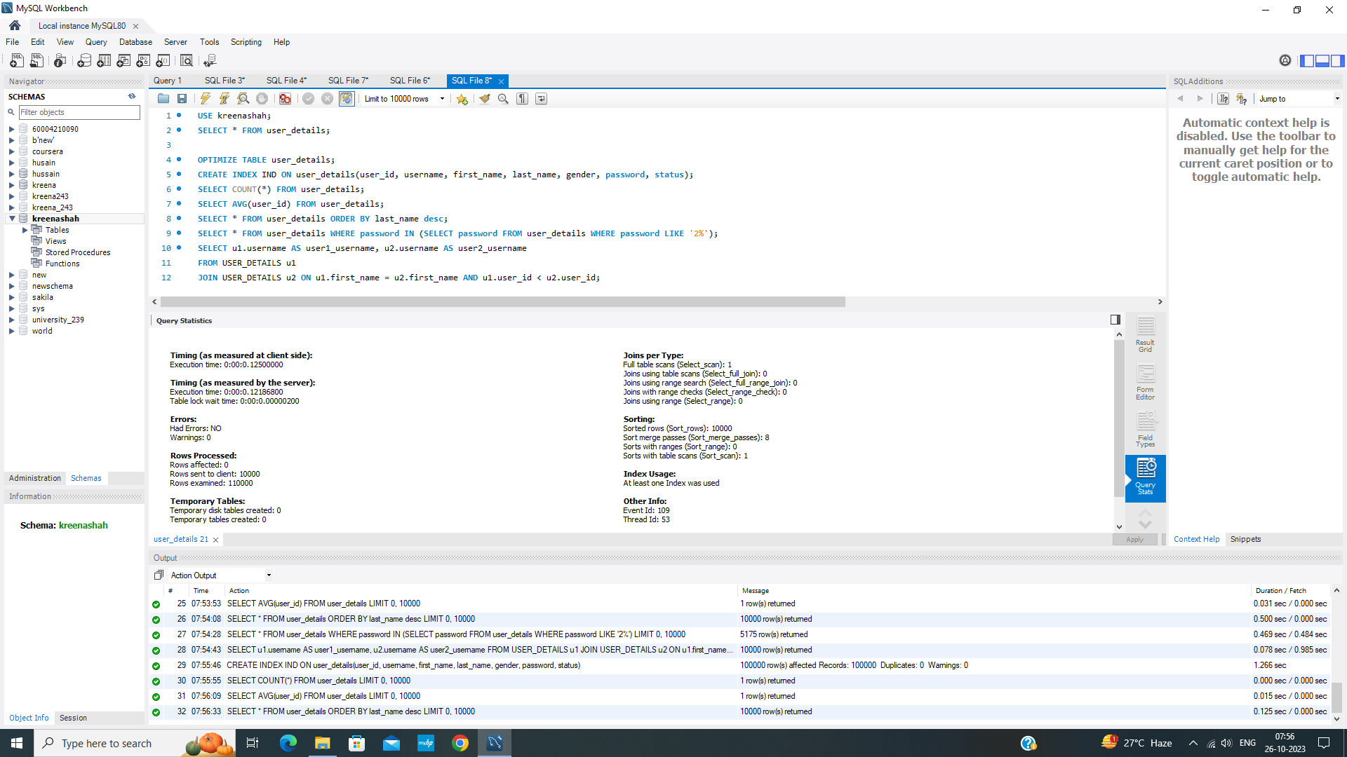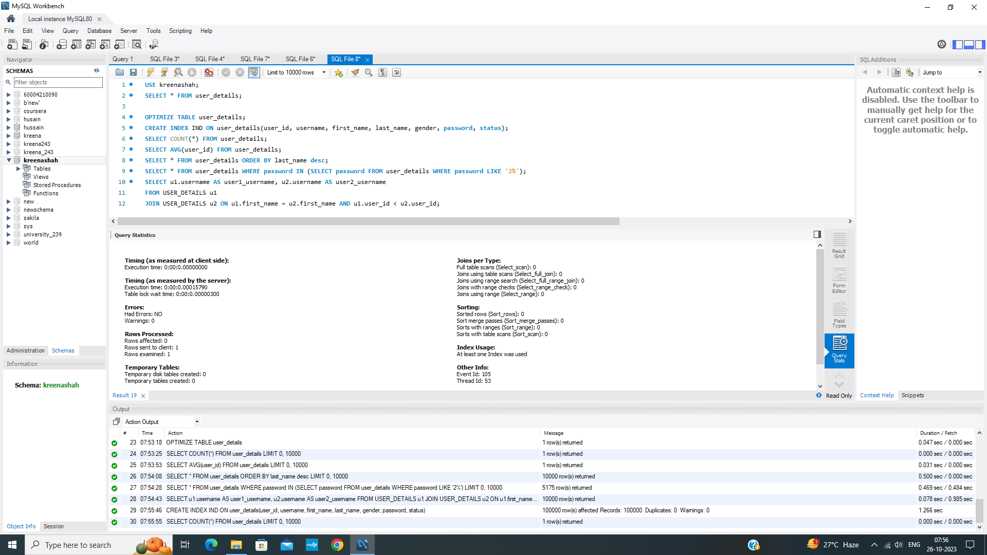

**Experiment No 3 - Query Monitoring**

Aim : Implementation of Query monitor (QEP- Query Execution

Plan, Query Statistics)

Write Ups :

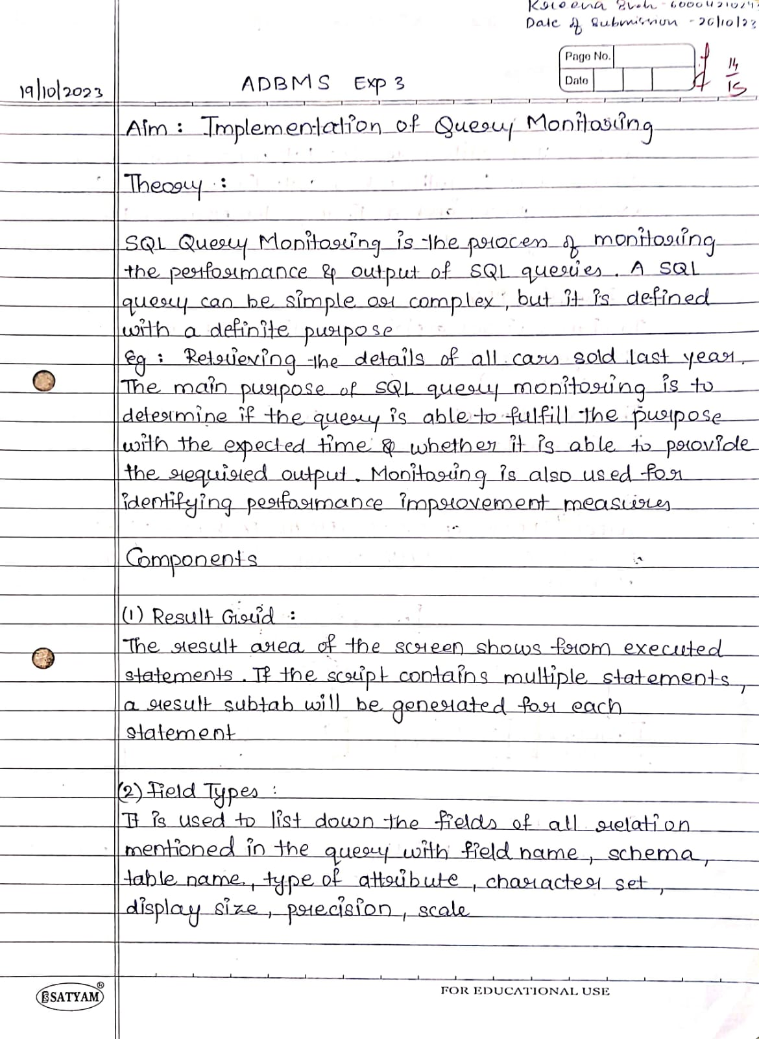

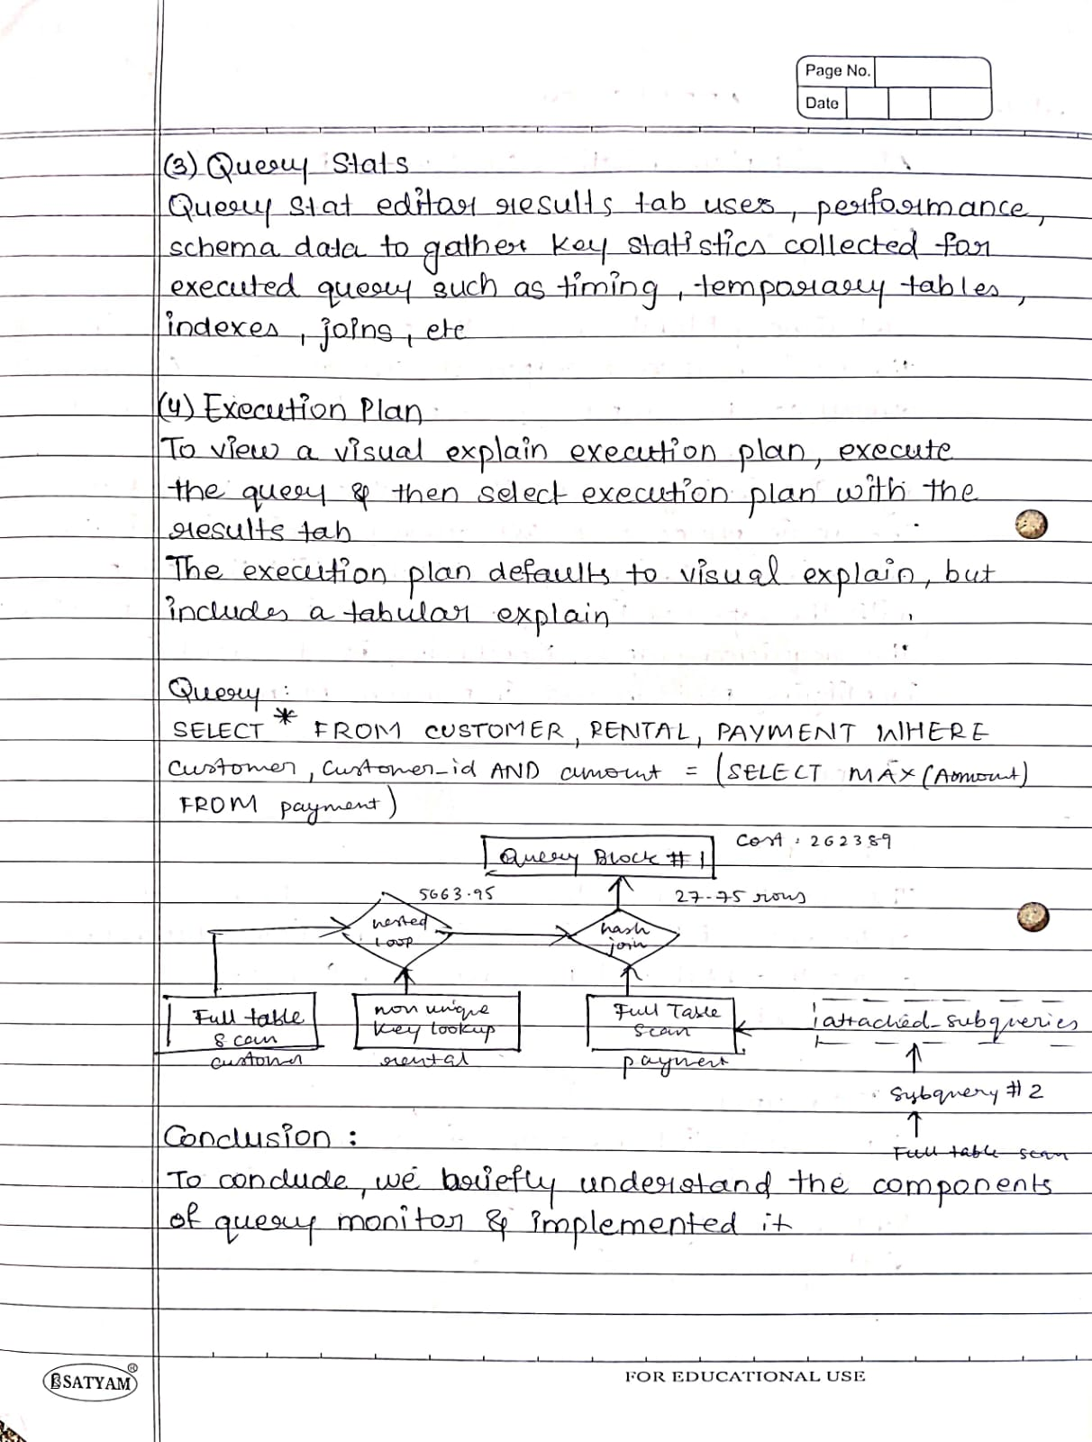

Screenshots : 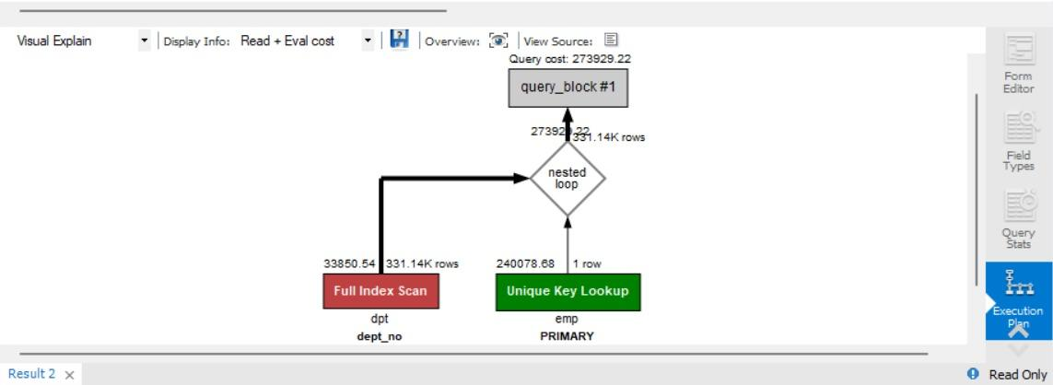

**Experiment No 4**

Aim : Optimization Using B & B+ Trees

Write Ups :

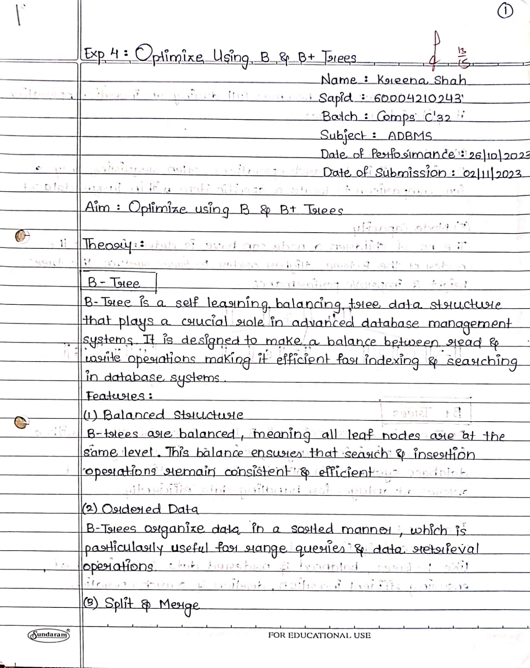

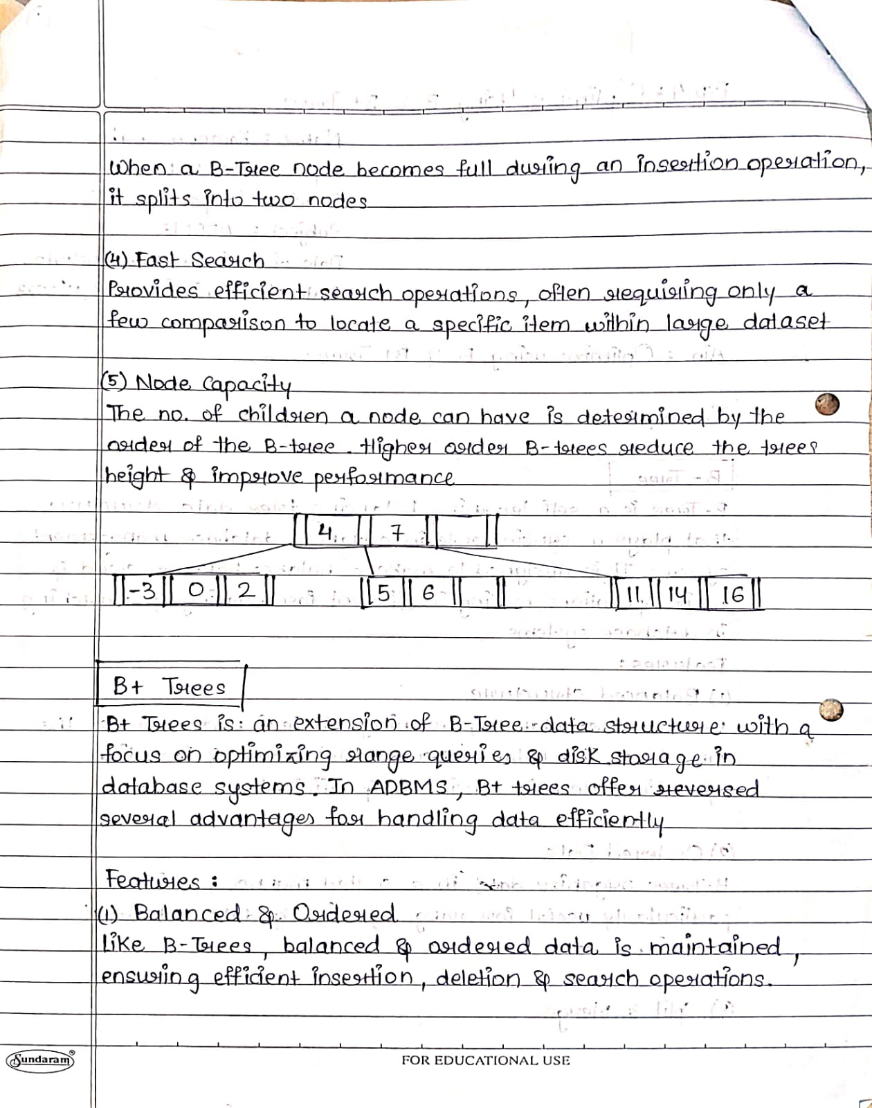

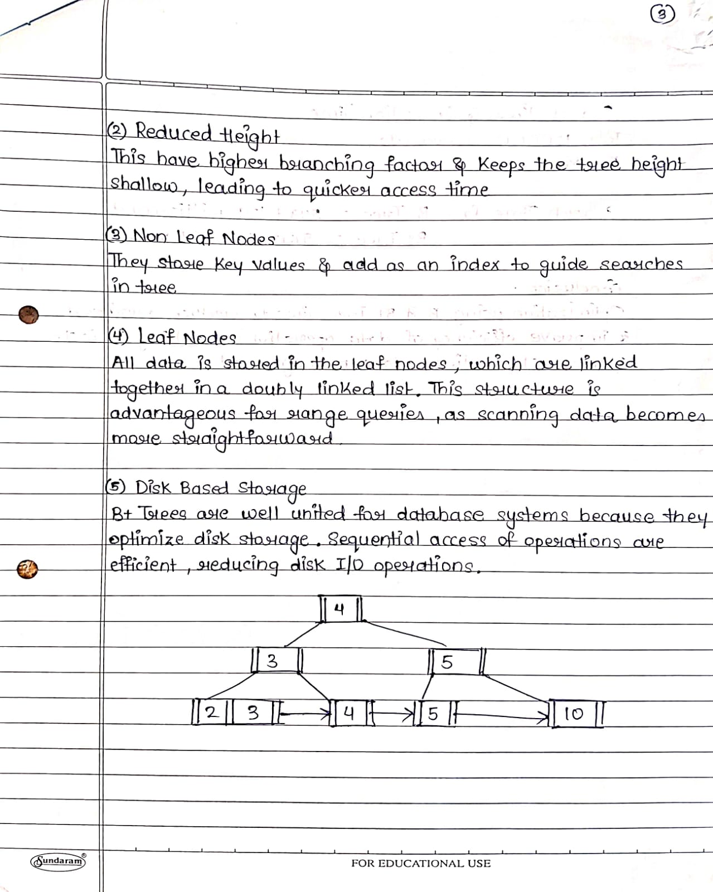

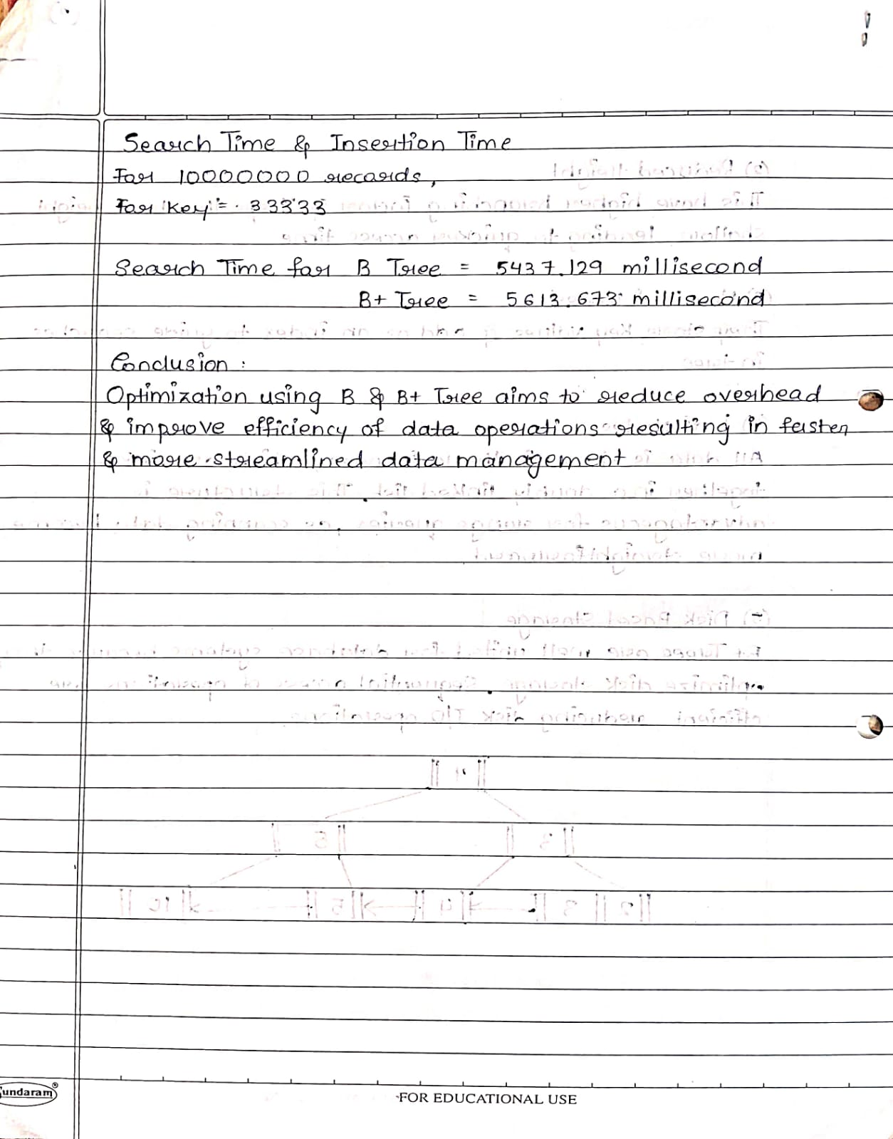

Screenshots :

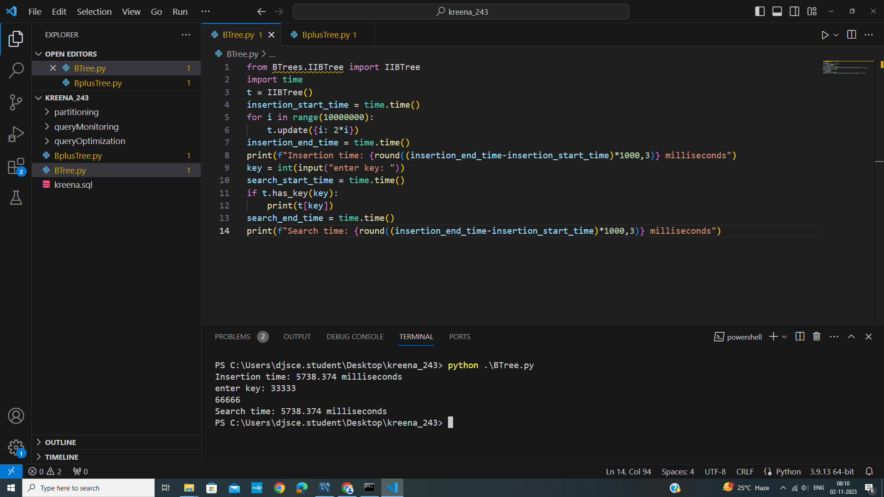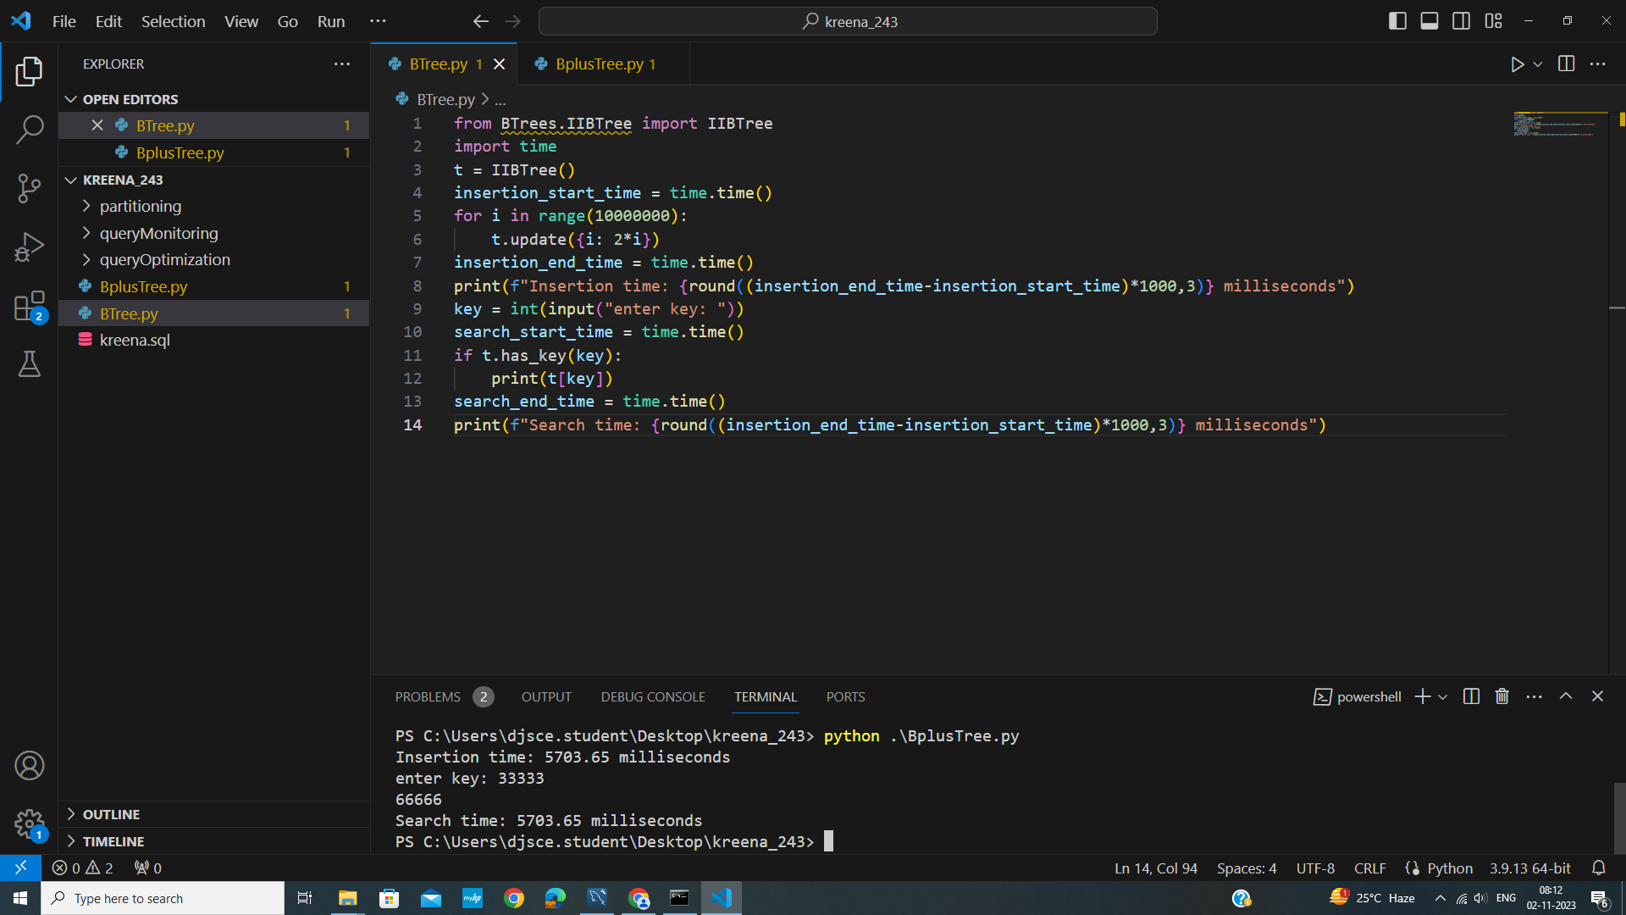

**Experiment No 5 - Distributed Database Design**

Aim : Perform Fragmentation (Range, List, Hash and Key) in DDBS design.

Write Ups :

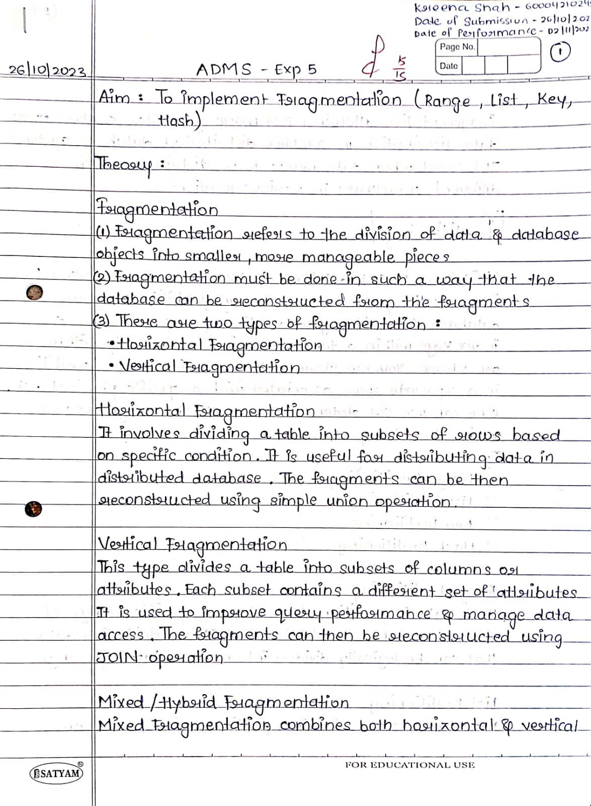

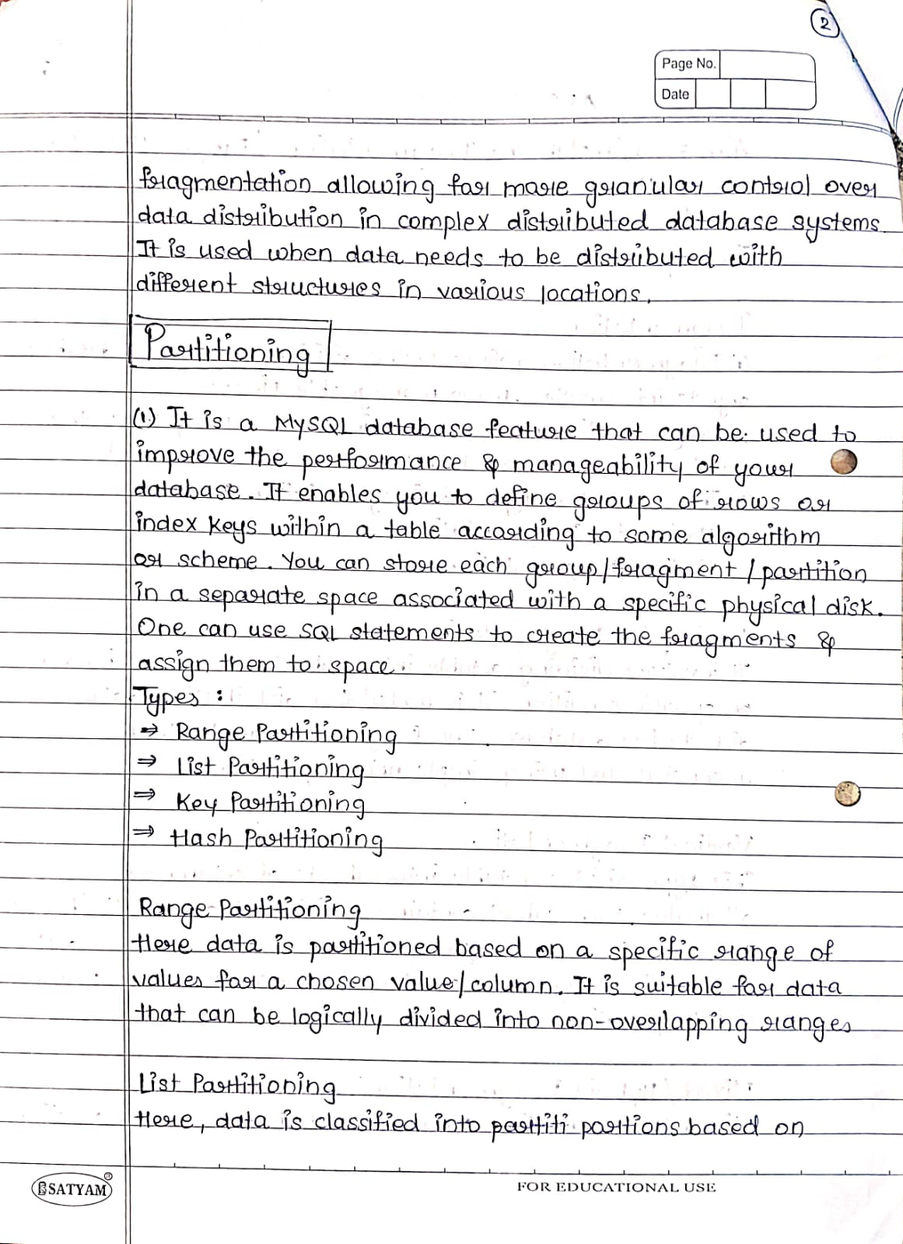

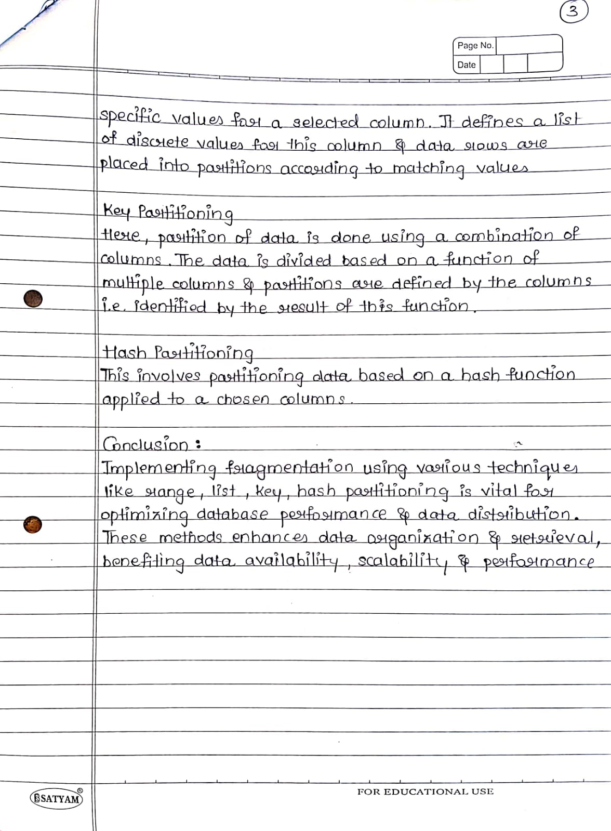

Screenshots :

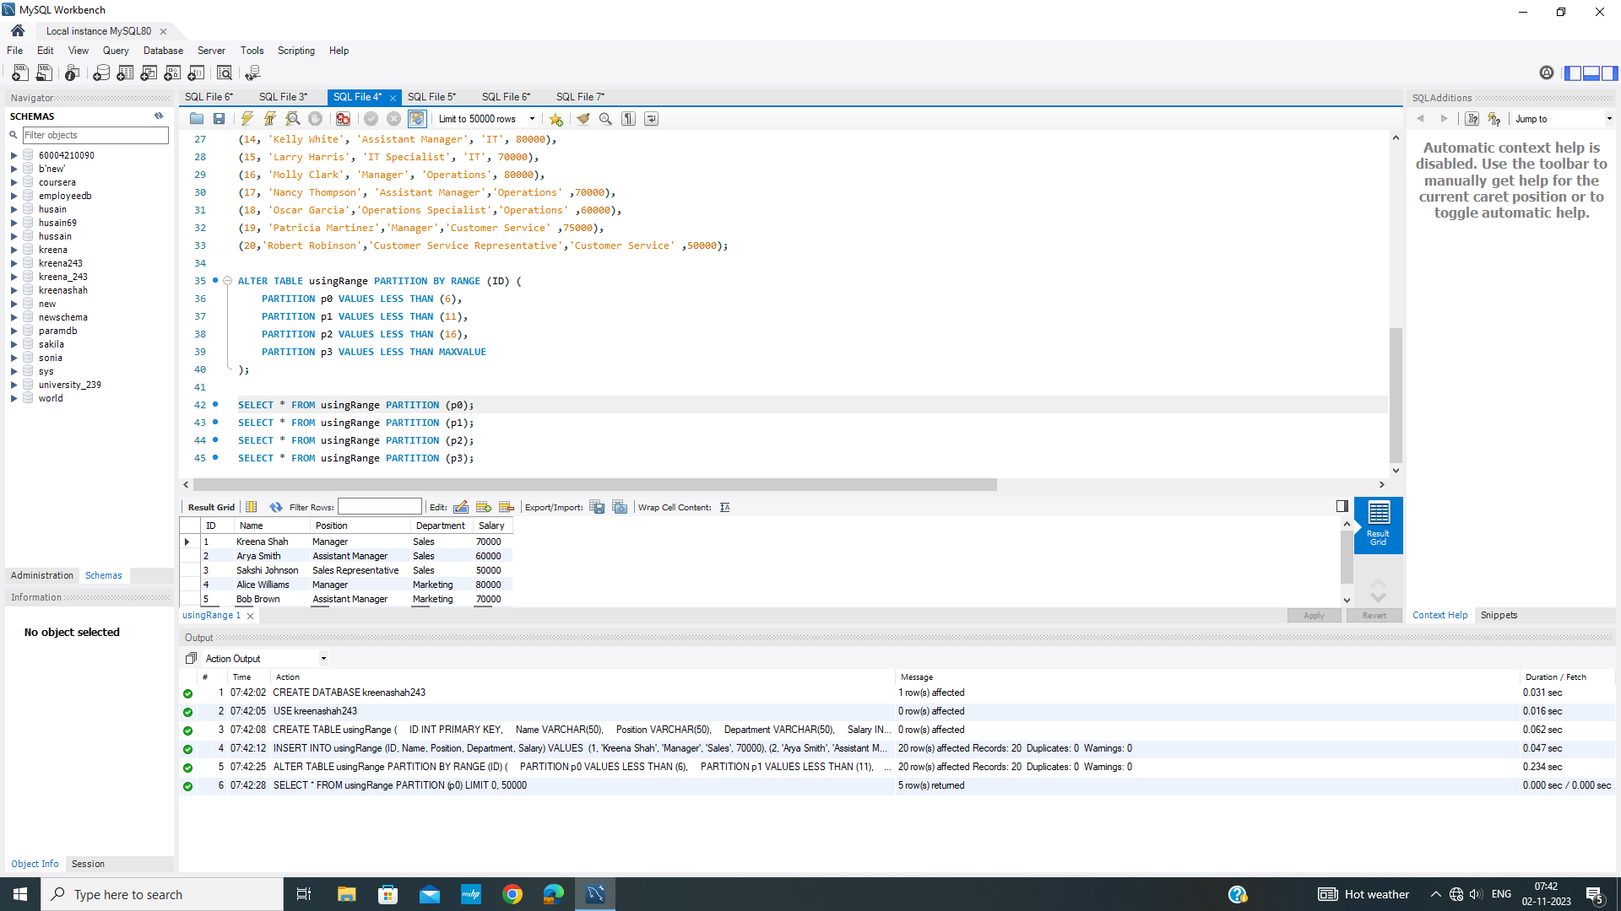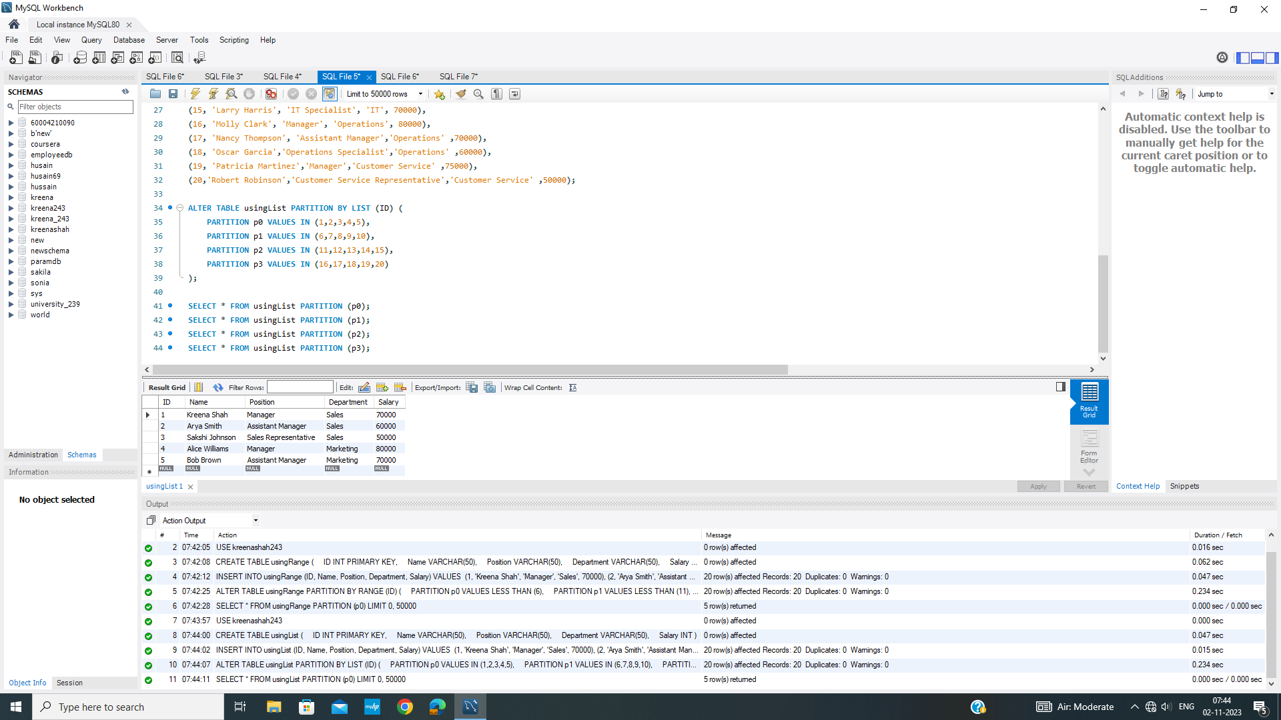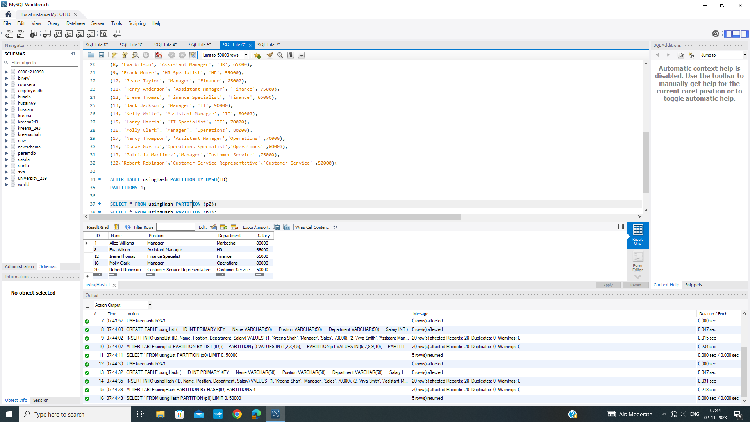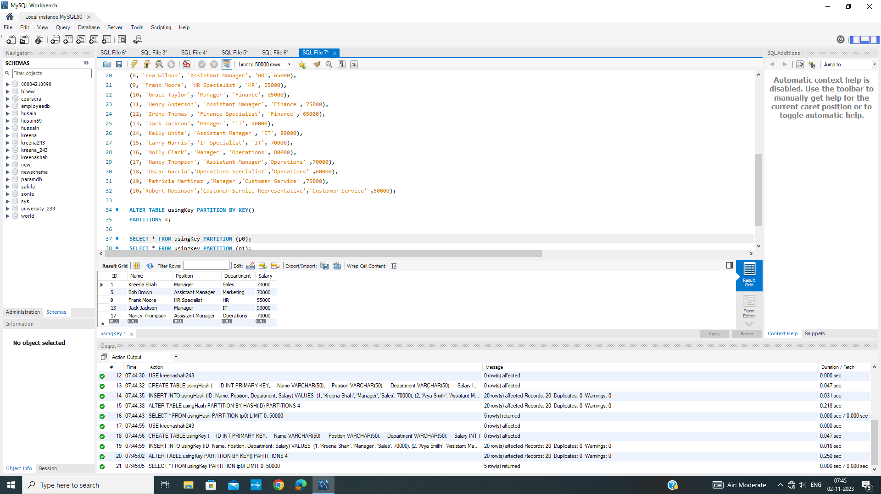

**Experiment No 7 - XML Programming**

Aim : Query execution on XML database.

Write Ups :

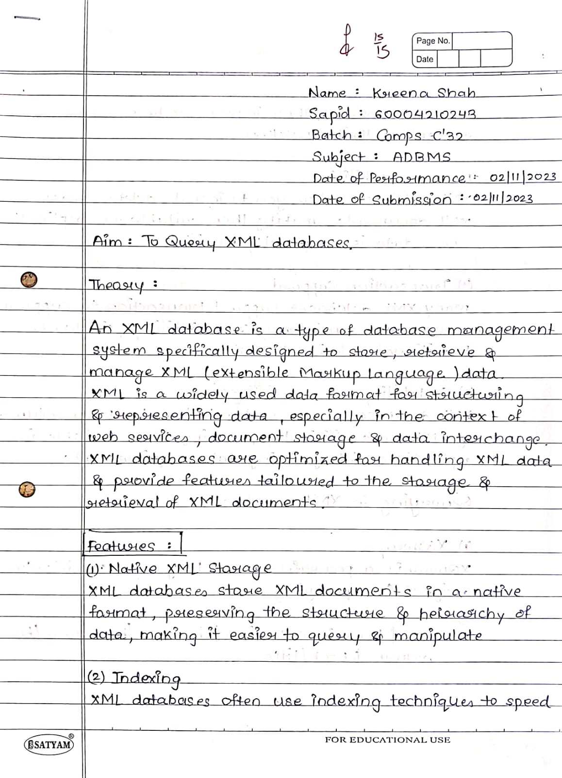

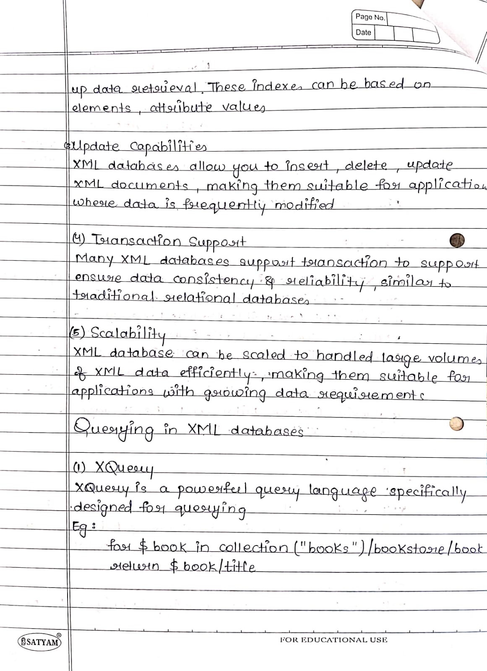

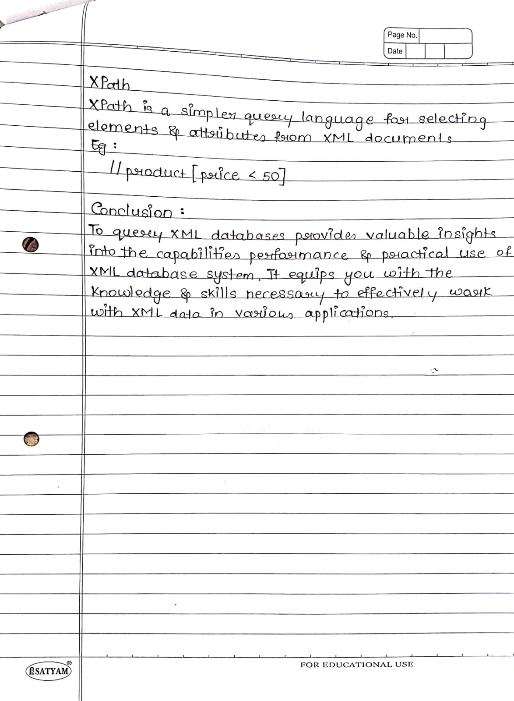

Code :

<!DOCTYPE html>

<html>

<head>

<title>XML Catalog</title>

</head>

<body>

<h1>Book Catalog</h1>

<input type="text" id="titleInput" placeholder="Search by Title">

<input type="text" id="authorInput" placeholder="Search by Author">

<input type="text" id="genreInput" placeholder="Search by Genre">

<input type="number" id="priceInput" placeholder="Search by Price">

<input type="date" id="dateInput" placeholder="Search by Publish Date">

<button onclick="searchBooks()">Search</button>

<ul id="bookList"></ul>

<script>

var catalogData; // Store the XML data for searching

// Function to load and parse the XML file

function loadXML() {

var xhttp = new XMLHttpRequest();

xhttp.onreadystatechange = function() {

if (this.readyState === 4 && this.status === 200) {

catalogData = this.responseXML; // Store the XML data for searching

displayCatalog(catalogData);

}

};

xhttp.open("GET", "book.xml", true);

xhttp.send();

}

// Function to display the catalog data

function displayCatalog(xml) {

var books = xml.getElementsByTagName("book");

var list = document.getElementById("bookList");

for (var i = 0; i < books.length; i++) {

var book = books[i];

var author = book.getElementsByTagName("author")[0].textContent;

var title = book.getElementsByTagName("title")[0].textContent;

var genre = book.getElementsByTagName("genre")[0].textContent;

var price = parseFloat(book.getElementsByTagName("price")[0].textContent);

var publishDate = new Date(book.getElementsByTagName("publish_date")[0].textContent);

var description = book.getElementsByTagName("description")[0].textContent;

var listItem = document.createElement("li");

listItem.innerHTML = "<strong>Title:</strong> " + title + "<br>" +

"<strong>Author:</strong> " + author + "<br>" +

"<strong>Genre:</strong> " + genre + "<br>" +

"<strong>Price:</strong> $" + price.toFixed(2) + "<br>" +

"<strong>Publish Date:</strong> " + publishDate.toDateString() + "<br>" +

"<strong>Description:</strong> " + description + "<br>";

list.appendChild(listItem);

}

}

// Function to search books based on user input

function searchBooks() {

var title = document.getElementById("titleInput").value.toLowerCase();

var author = document.getElementById("authorInput").value.toLowerCase();

var genre = document.getElementById("genreInput").value.toLowerCase();

var price = parseFloat(document.getElementById("priceInput").value);

var date = new Date(document.getElementById("dateInput").value);

var list = document.getElementById("bookList");

list.innerHTML = ""; // Clear the previous list

var books = catalogData.getElementsByTagName("book");

for (var i = 0; i < books.length; i++) {

var book = books[i];

var bookTitle = book.getElementsByTagName("title")[0].textContent.toLowerCase();

var bookAuthor = book.getElementsByTagName("author")[0].textContent.toLowerCase();

var bookGenre = book.getElementsByTagName("genre")[0].textContent.toLowerCase();

var bookPrice = parseFloat(book.getElementsByTagName("price")[0].textContent);

var bookDate = new Date(book.getElementsByTagName("publish_date")[0].textContent);

if (

(title === "" || bookTitle.includes(title)) &&

(author === "" || bookAuthor.includes(author)) &&

(genre === "" || bookGenre.includes(genre)) &&

(isNaN(price) || price === bookPrice) &&

(isNaN(date) || date.toDateString() === bookDate.toDateString())

) {

var description = book.getElementsByTagName("description")[0].textContent;

var listItem = document.createElement("li");

listItem.innerHTML = "<strong>Title:</strong> " + bookTitle + "<br>" +

"<strong>Author:</strong> " + bookAuthor + "<br>" +

"<strong>Genre:</strong> " + bookGenre + "<br>" +

"<strong>Price:</strong> $" + bookPrice.toFixed(2) + "<br>" +

"<strong>Publish Date:</strong> " + bookDate.toDateString() + "<br>" +

"<strong>Description:</strong> " + description + "<br>";

list.appendChild(listItem);

}

}

}

// Load and display the XML data when the page loads

window.onload = function() {

loadXML();

};

</script>

</body>

</html>

Database (sample book added here)

<?xml version="1.0"?>

<catalog>

<book id="bk101">

<author>Gambardella, Matthew</author>

<title>XML Developer's Guide</title>

<genre>Computer</genre>

<price>44.95</price>

<publish_date>2000-10-01</publish_date>

<description>An in-depth look at creating applications

with XML.</description>

</book>

</catalog>

Screenshots :

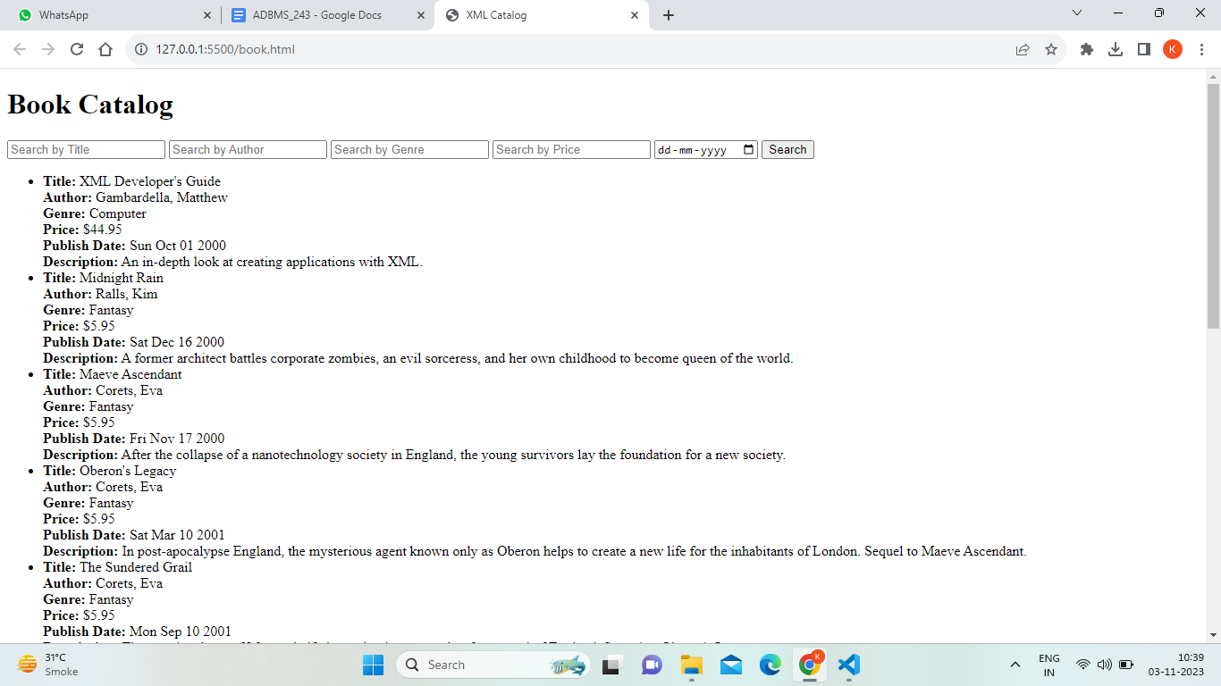

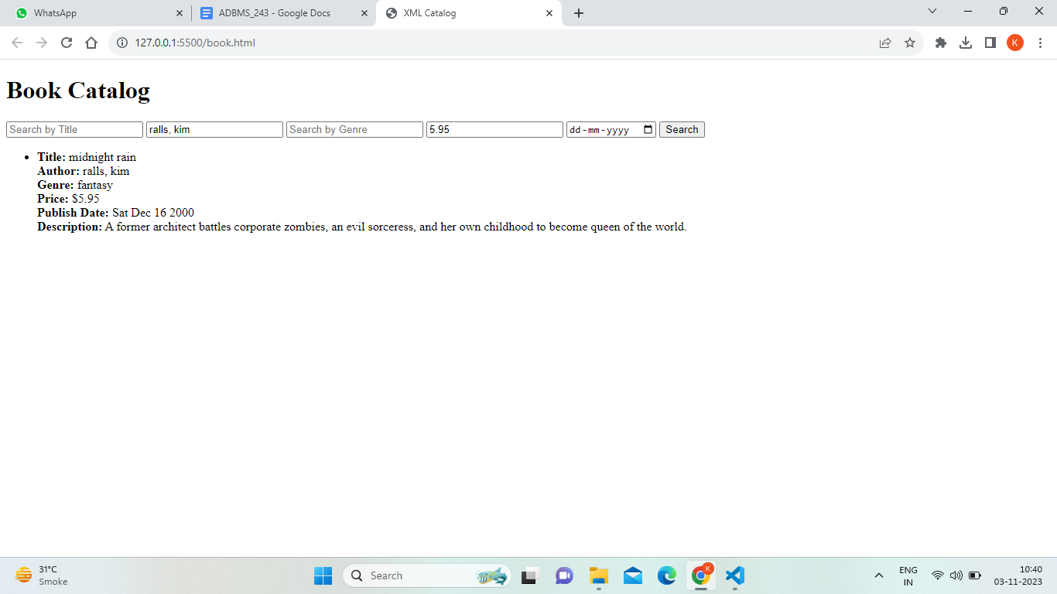

**Experiment No 8 - Document Database**

WriteUp : 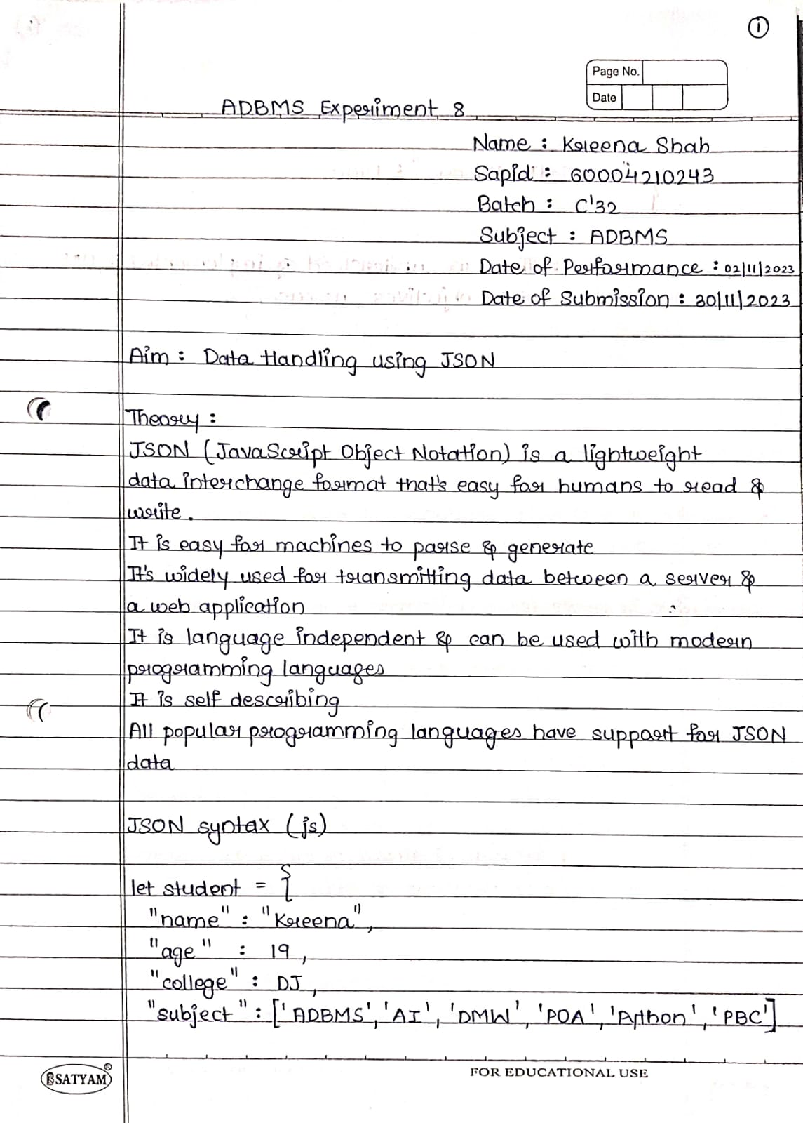

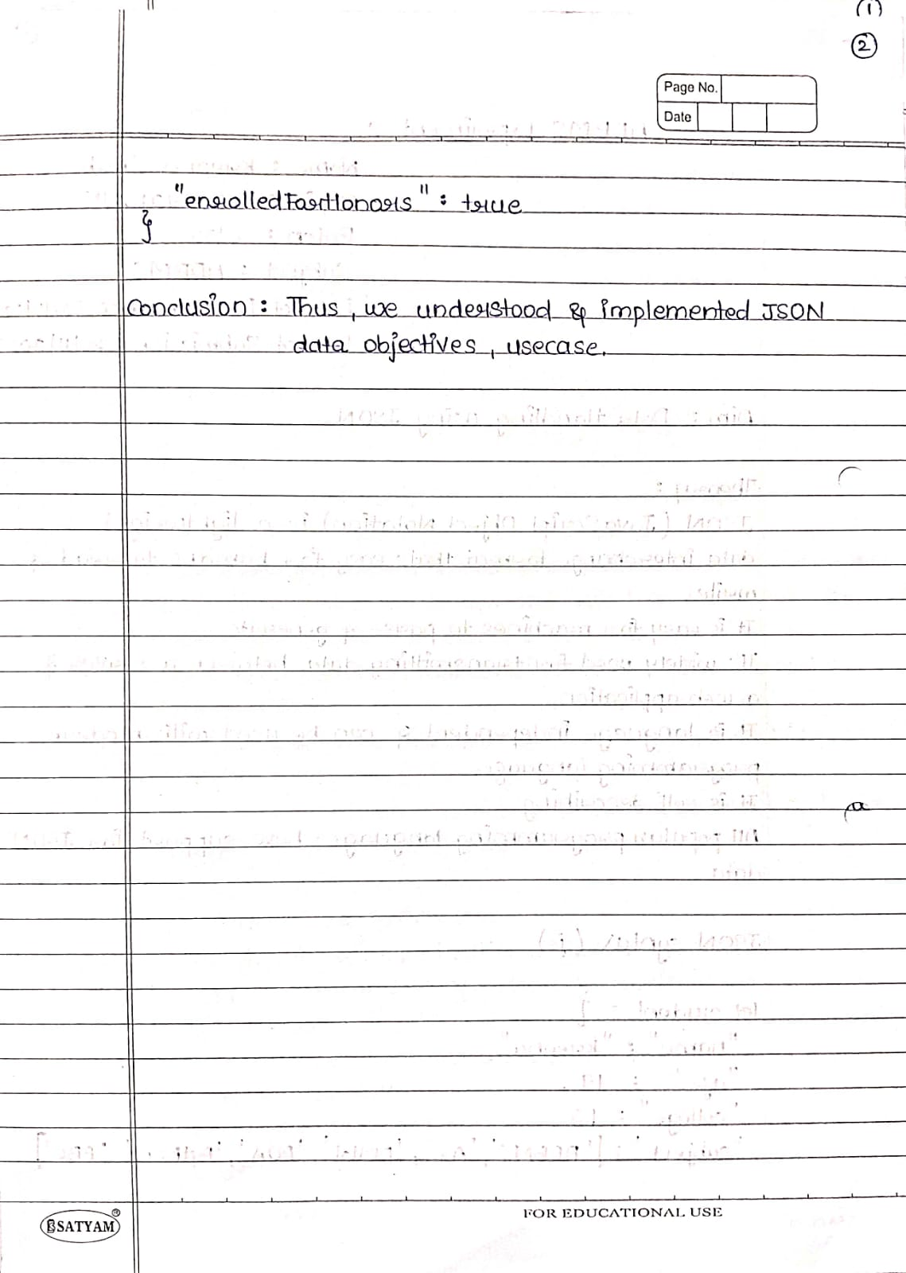

Code / Screenshots : 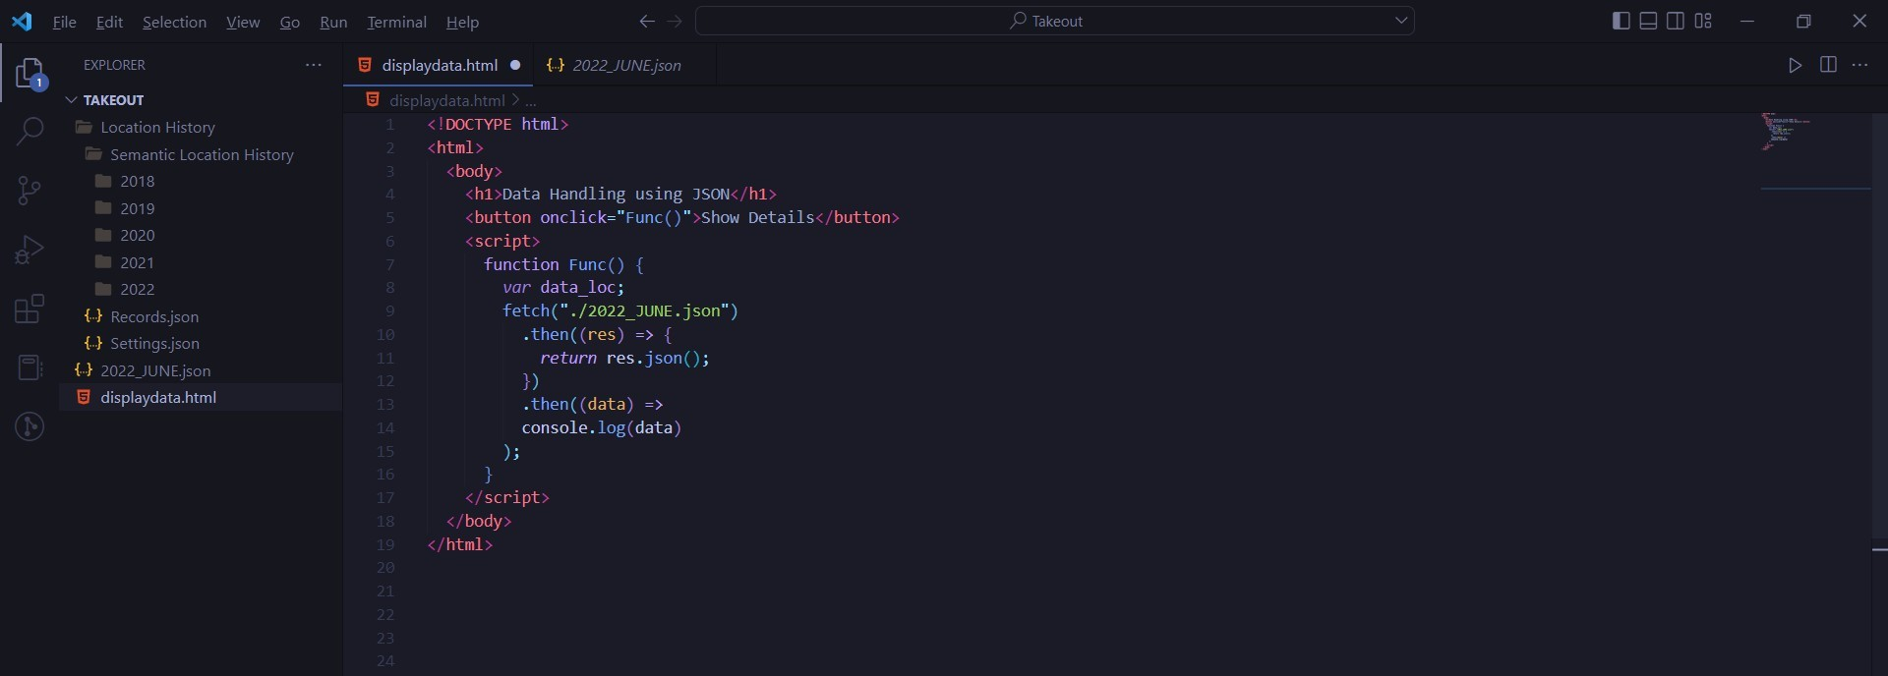

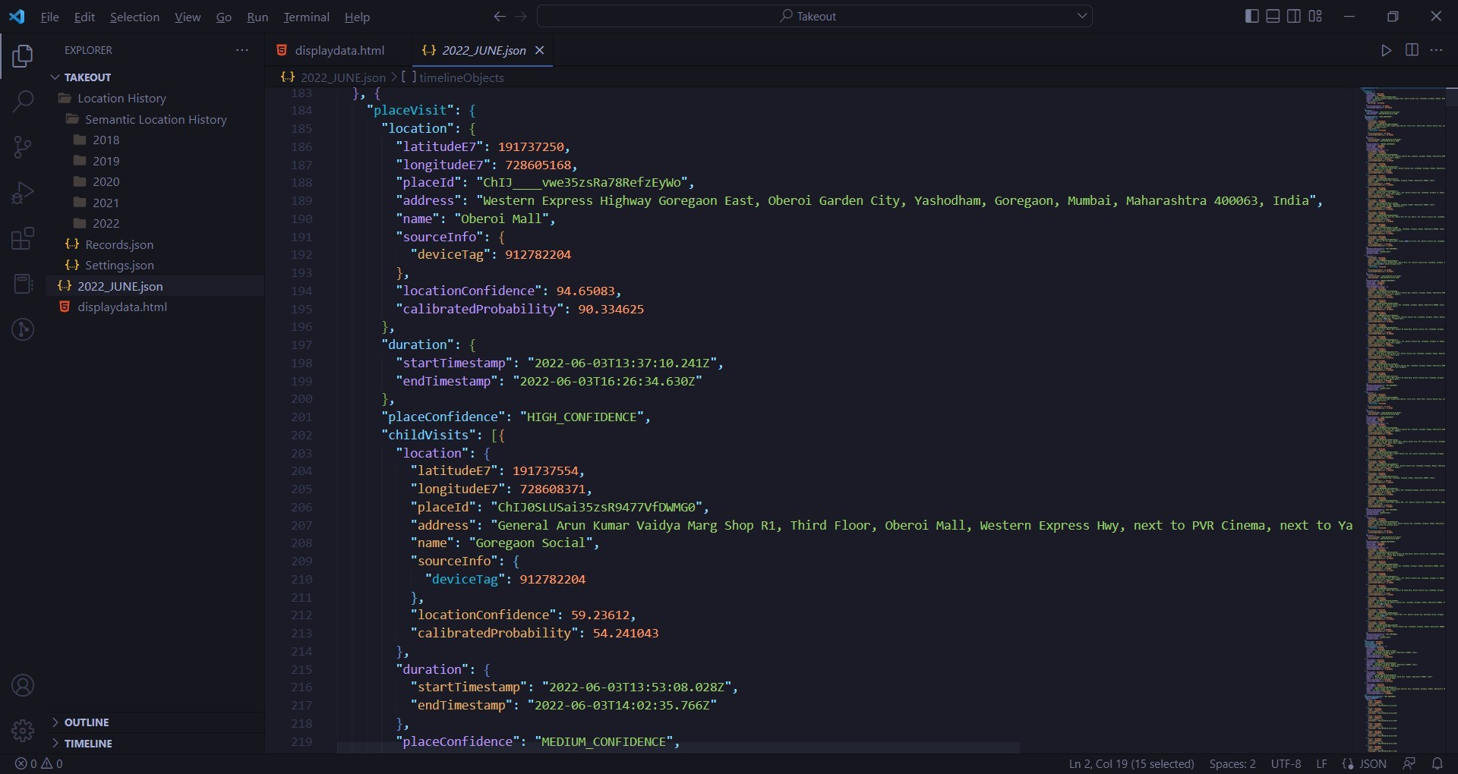

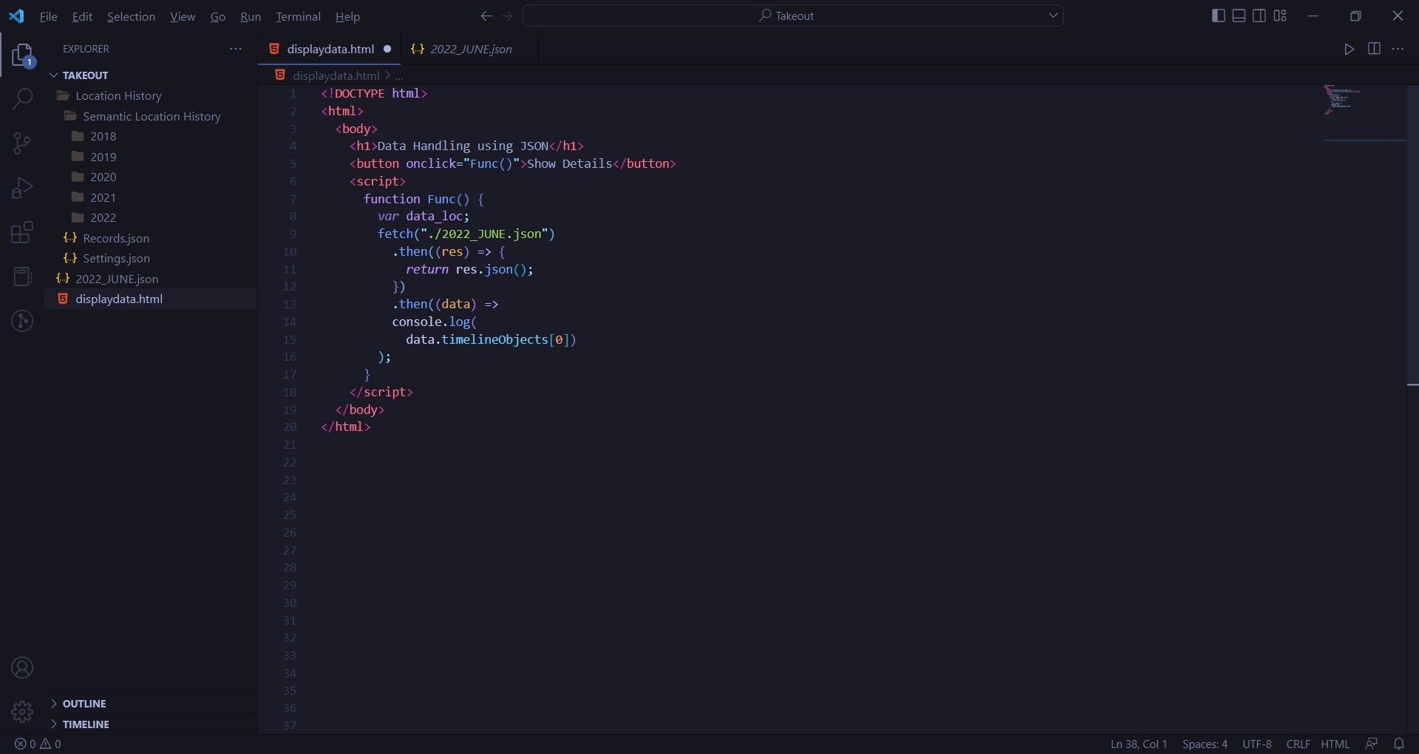

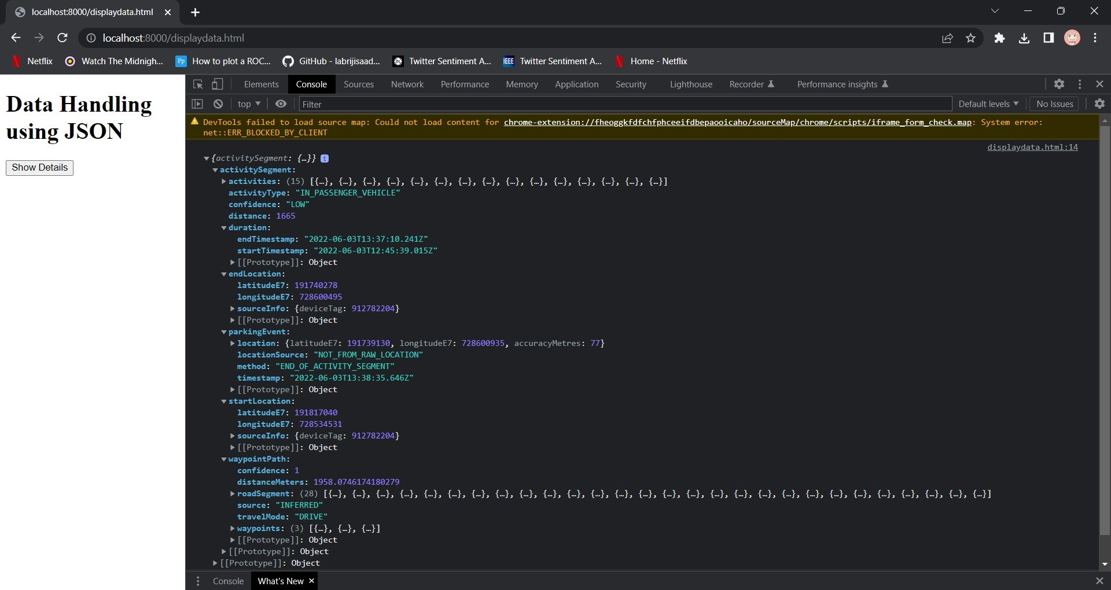

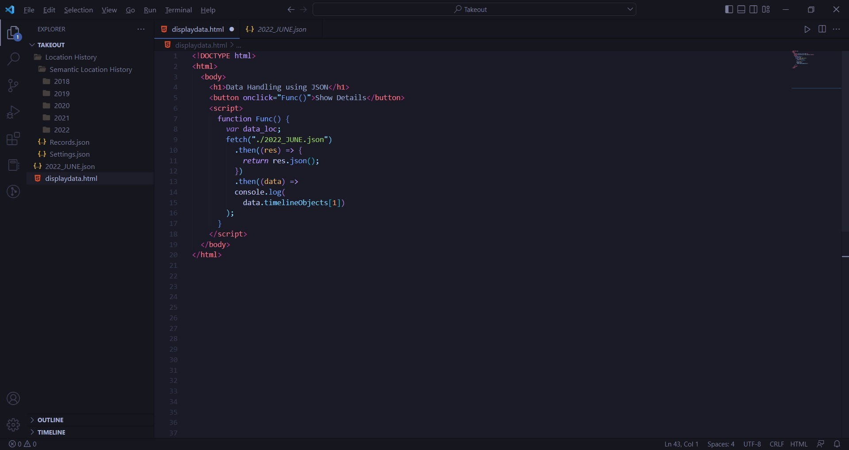

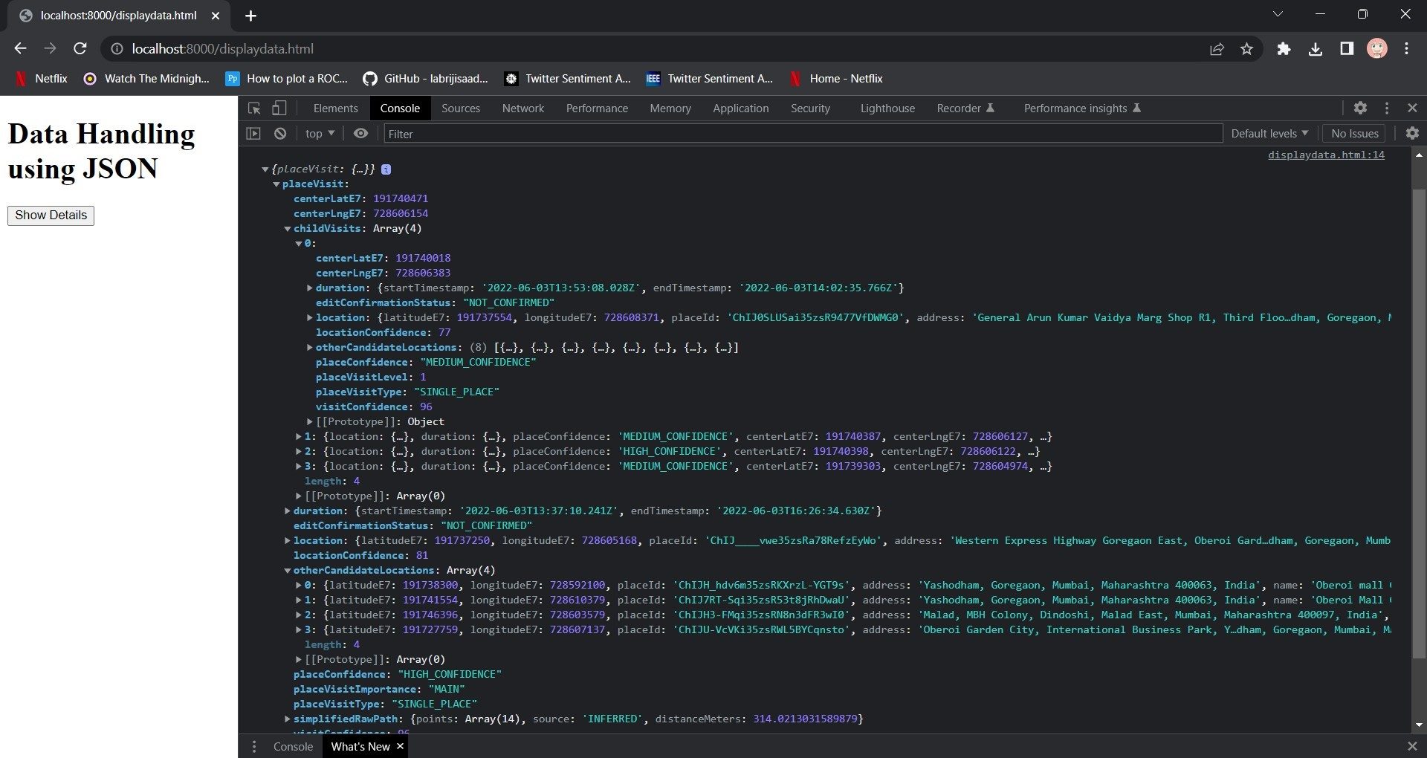

**Experiment No. 9 - Spatial and Temporal Data Handling** 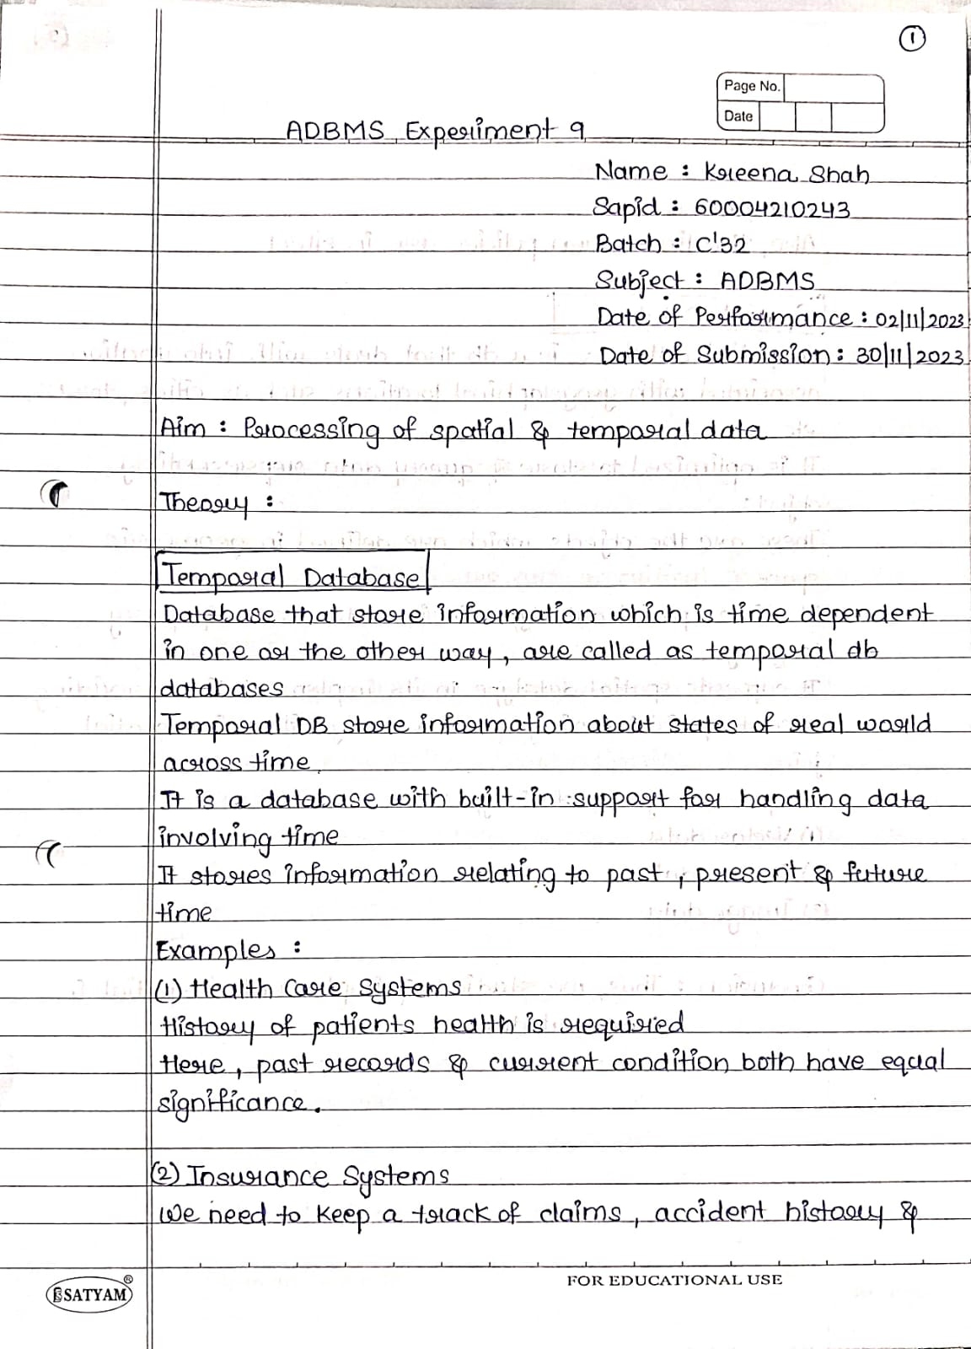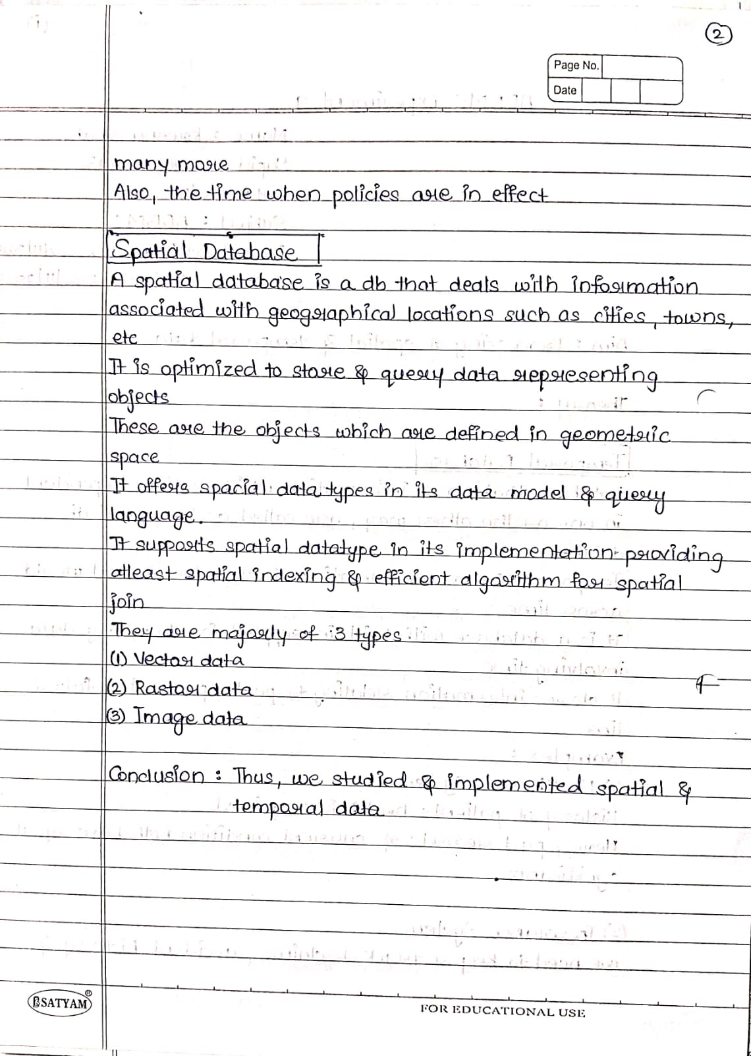

Code:

const data = {"type" : "FeatureCollection", "features" : [{"type" :

"Feature", "geometry" :

{"type" : "Point",

"coordinates" : [[122.0, 10.0],

[113.0, 2.0],

[14.0, 0.0],

[235.0, 1.0]]},

"properties" : {"Name" : "Redwood City", "time" : 14.0}},

{"type" : "Feature",

"geometry" : {"type" : "LineString",

"coordinates" : [[102.0, 0.0],

[103.0, 1.0],

[104.0, 0.0],

[105.0, 1.0]]},

"properties" : {"Name" : "USA", "time" : 24.0}},

{"type" : "Feature",

"geometry" : {"type" : "Polygon",

"coordinates" : [[[100.0, 0.0],

[101.0, 0.0],

[101.0, 1.0],

[100.0, 1.0],

[100.0, 0.0]]]},

"properties" : {"Name" : "Ghatkopar", "prop1" : {"this" :

"that"}}}]} const features = data["features"] features.map(feature =>

{

const coordindates = feature.geometry.coordinates; if(coordindates[0][0] > 100 && coordindates[0][1] < 102 && feature.properties.time > 20){

console.log(feature.properties)

}

})

Screenshots :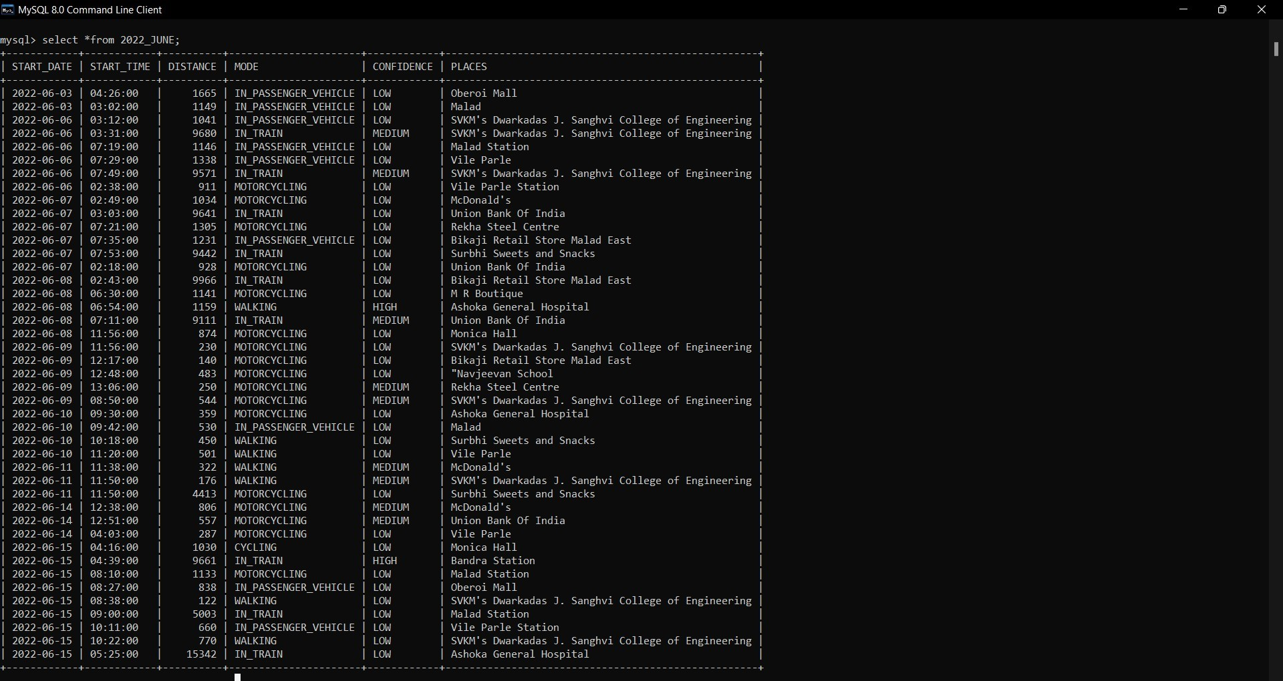

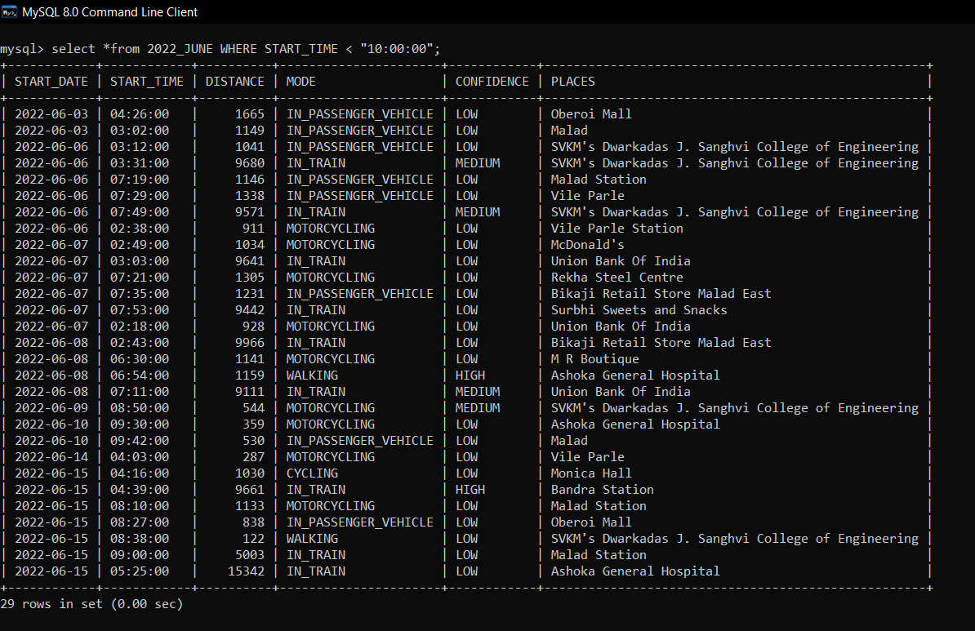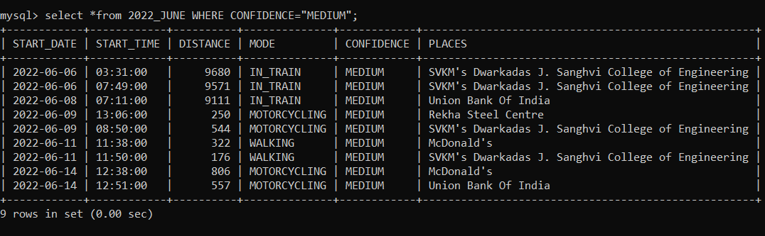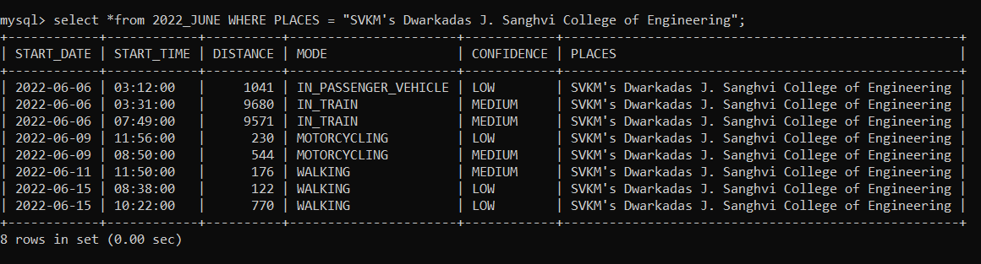

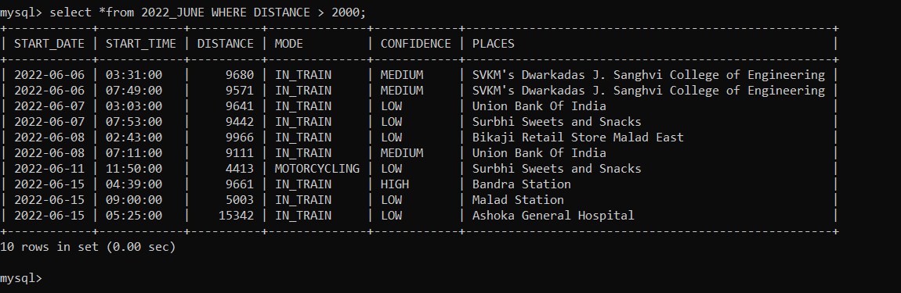

**Experiment No 10 - Case study**

WriteUp : 